PRESS RELEASE

EWMA 2023: Freudenberg presents elastic, superabsorbent nonwovens and flexible silicone foam dressings

Weinheim, April 27, 2023. Freudenberg Performance Materials (Freudenberg) is expanding its product portfolio by adding an elastic variant of its flexible superabsorbers for modern wound dressings. These superabsorbers increase the comfort level for patients as well as enabling longer wear time, thus reducing the frequency of dressing changes. Further highlights at EWMA include components for more sustainable wound care, PU foams with directly applied silicone adhesives, antimicrobial systems and an innovative hydrophilic debridement foam. The global manufacturer will be welcoming visitors to Exhibition Stand 100 in Milan from May 3 – 5.

Freudenberg uses a new technology to manufacture the elastic superabsorbers. Unlike other methods, this technology does not perforate or slit the material, thus achieving a high degree of consistent elasticity. Furthermore, the technology used by Freudenberg bonds the superabsorbent fibers more uniformly with the material, thus enhancing the integrity of this layer in the wound dressing.

Further highlights
Freudenberg is also presenting the M 1714 wound pad component, one example of a sustainable solution that simultaneously delivers on performance. The dressing consists of bio-based fibers and exhibits a smooth wound contact layer. M 1714 has been evaluated for industrial compostability and conforms to ISO 13432. This enables certification of product biodegradability. Further highlights to be presented in Milan include material systems for the antimicrobial treatment of chronic wounds, including systems that do not use active substances.

Wound dressing with silicone adhesive border
With Freudenberg’s silicone coated foams, manufacturers can reduce the number of process steps, thereby avoiding waste, saving energy and simplifying the supply chain. Compared with conventional foam dressings, the Freudenberg foam product also offers higher flexibility for optimal wound bed contouring and reduces the risk of infection by preventing exudate pooling. Freudenberg is showcasing the prototype of a bordered dressing with a silicone adhesive border. In addition, the variant with an extra-strong silicone border enables longer wear time while at the same time ensuring minimal adherence to new skin that forms at the wound edges.

More effective cleansing results and greater patient comfort
Freudenberg is also showcasing an innovative hydrophilic debridement foam. It is ideally suited for use in wound cavities, offers better cleansing results and reduced risk as well as greater patient comfort.

Illustration:
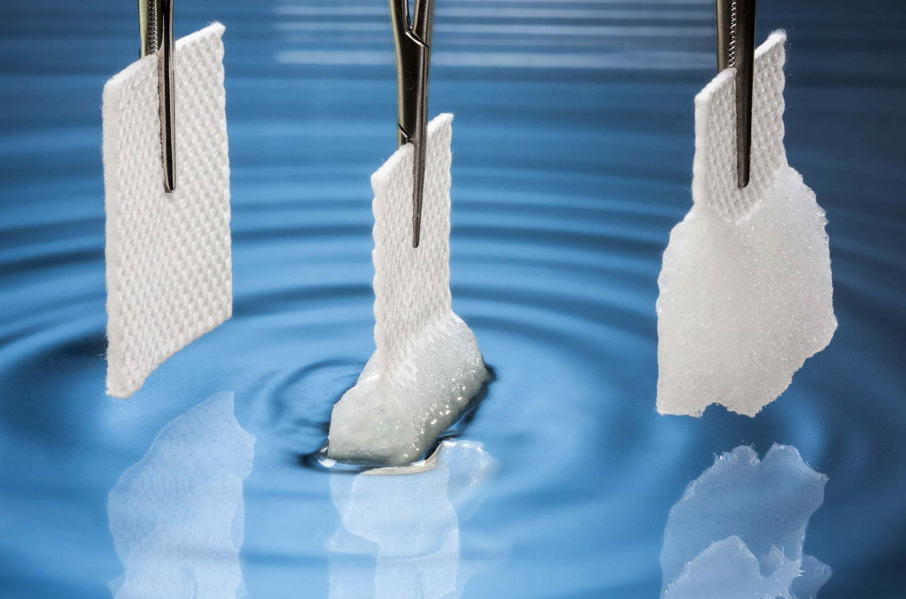
Freudenberg now offers an elastic variant of this superabsorber for modern wound dressings.

Contacts for media inquiries
Freudenberg Performance Materials Holding GmbH
Holger Steingraeber, SVP Global Marketing & Communications
Höhnerweg 2-4 / 69469 Weinheim / Germany
Tel. +49 6201 7107 007
Holger.Steingraeber@freudenberg-pm.com
www.freudenberg-pm.com

Katrin Böttcher, Manager Global Media Relations
Höhnerweg 2-4 / 69469 Weinheim / Germany
Tel. +49 6201 7107 014
Katrin.Boettcher@freudenberg-pm.com

About Freudenberg Performance Materials
Freudenberg Performance Materials is a leading global supplier of innovative technical textiles for a broad range of markets and applications such as apparel, automotive, building interiors, building materials, healthcare, energy, filter media, shoe and leather goods as well as specialties. In 2022, the company generated sales of some €1.6 billion, had 32 production sites in 14 countries around the world and had more than 5.000 employees. Freudenberg Performance Materials attaches great importance to social and ecological responsibility as the basis for its business success. For more information, please visit www.freudenberg-pm.com. In 2022, the Freudenberg Group employed more than 51,000 people in around 60 countries worldwide and generated sales of more than €11,7 billion. For more information, please visit www.freudenberg.com.

