**PRESS RELEASE**

Compamed 2017: Freudenberg presents innovations in modern wound care

**Weinheim, November 13, 2017. Freudenberg Performance Materials is presenting three additions to its foam portfolio: a direct coating of silicone adhesives, MDI-based PU foams, and superabsorbent nonwoven laminates. Activated carbon filters for ostomy applications are a further highlight at the stand. Freudenberg Performance Materials can be found in Hall 8b / Stand H01 at Compamed 2017.**

**Direct coating improves performance of foams**

The globally active developer and manufacturer of multilayer material systems comprising hydrophilic PU foams and hydroactive nonwovens is debuting foams with a direct coating of silicone adhesives. Thanks to the adhesive properties of silicone, such coatings not only make it easier to apply the foam dressing, they also minimize trauma during dressing changes. Compared with conventional transfer coatings the patent pending innovation has several advantages. It enables customers to offer wound dressings that are significantly more flexible than conventional products and adapt better to the wound bed. Furthermore, the effectiveness of antimicrobial finishes is improved. In addition, the reduction in the number of process steps and a lower level of complexity saves energy, reduces waste and simplifies the supply chain.

**Faster absorption and greater strength of wound dressings**

Freudenberg Performance Materials is one of the first companies in the market to have developed an MDI-based PU foam. The innovation significantly surpasses the performance of commonly used TDI-based PU foams: "With our new MDI-based PU foam, our customers are able to offer modern wound dressings for chronic venous leg ulcers which absorb wound fluids much faster and have significantly better retention properties. In addition, these wound dressings are much stronger”, explained Marcus Simon, Manager Market Segment Medical at Freudenberg Performance Materials.

Higher absorption and retention of wound dressings

Following the introduction of an MDI-based foam last year, Freudenberg Performance Materials has continued with the systematic expansion of its portfolio in this field. With immediate effect, the company has begun ISO 13485-compliant series production of laminates comprising hydrophilic PU foams and hydroactive nonwovens. The combination of these two components, foam and nonwoven, can achieve a significant improvement in the absorption and retention of wound dressings. Customers can choose between MDI- and TDI-based foams.

Customized activated carbon filters for ostomy applications

High-performance activated carbon filters from Freudenberg Performance Materials are used as integrated activated carbon filters in ostomy bags, targeted at the adsorption of unpleasant odors. Freudenberg Performance Materials adapts them to the individual requirements and specifications of its customers. Thanks to the company’s ultra-modern production and finishing options, Freudenberg Performance Materials can offer a wide variety of ostomy filter variants, both on rolls and as a finished product. These can meet the specific requirements of ileostomy or colostomy products, for example.

Pictures and captions:

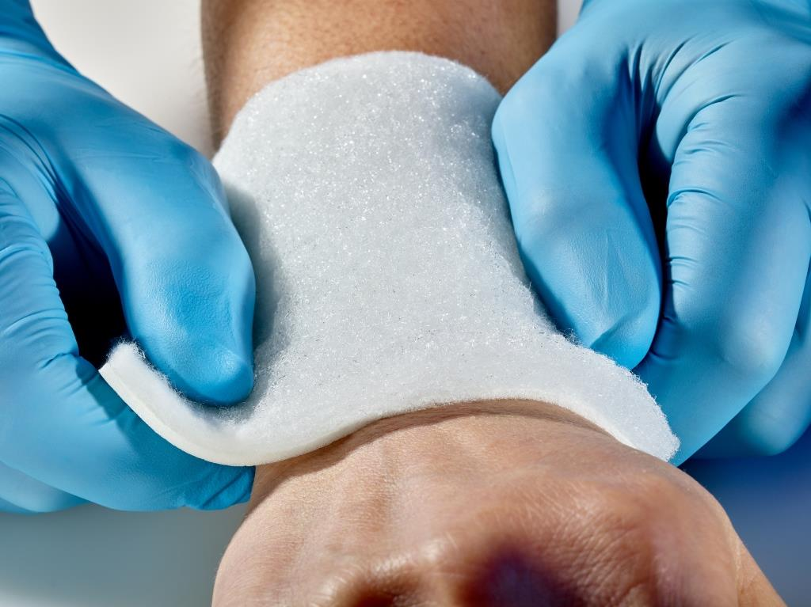

*Freudenberg´s PU foam/nonwoven laminate: The combination of foam and nonwoven can achieve a significant improvement in the absorption and retention of wound dressings.*

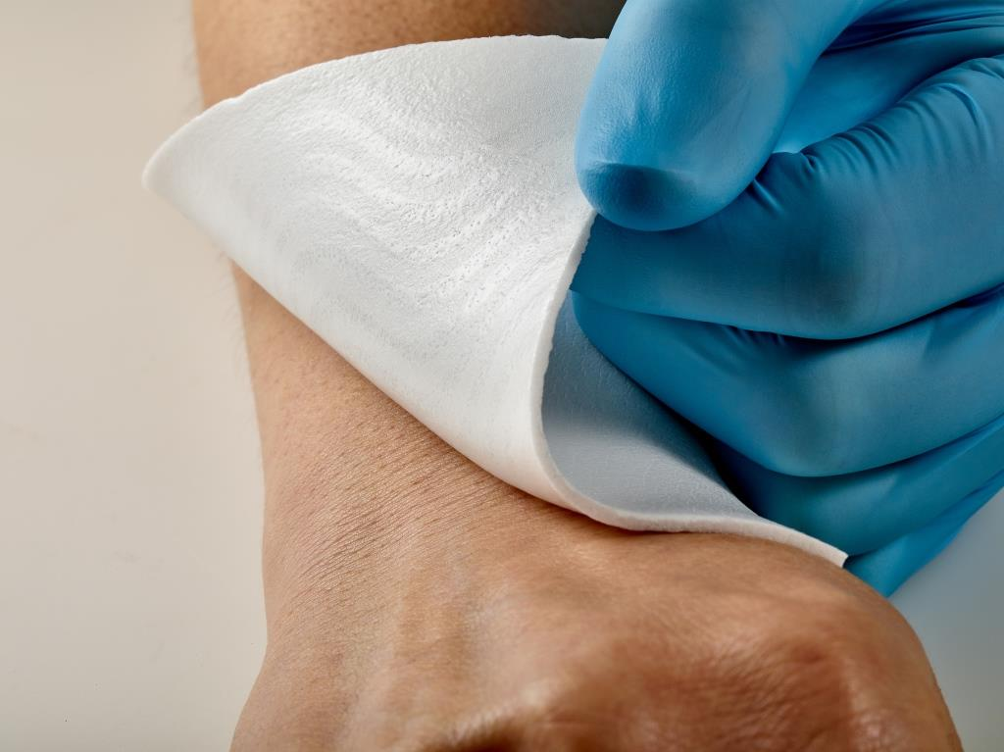

*Freudenberg´s PU foam with direct coating of silicone adhesives enables customers to offer wound dressings that are significantly more flexible that conventional products and adapt better to the wound bed.*

Contacts for media enquiries

Freudenberg Performance Materials Holding SE & Co. KG

Holger Steingraeber, Director Global Communications

Höhnerweg 2-4 / 69469 Weinheim / Germany

Phone +49 6201 80 6640

Holger.Steingraeber@freudenberg-pm.com

www.freudenberg-pm.com

Katrin Böttcher, Manager Global Communications

Höhnerweg 2-4 / 69469 Weinheim / Germany

Tel. +49 6201 80 5977

Katrin.Boettcher@freudenberg-pm.com

www.freudenberg-pm.com

About Freudenberg Performance Materials

Freudenberg Performance Materials is a leading global manufacturer of innovative technical textiles offering differentiated value propositions to a broad range of markets and applications such as Apparel, Automotive, Building Materials, Hygiene, Medical, Shoe and Leather goods as well as Specialties. In 2016, the company generates sales of more than €950 million and has 25 manufacturing sites in 14 countries and almost 3.800 employees. Freudenberg Performance Materials attaches great importance to social and ecological responsibility. For more information, please visit www.freudenberg-pm.com

In 2016, the Freudenberg Group employed more than 48,000 people in almost 60 countries worldwide and generated sales of approximately €8.6 billion (including pro-rata consolidation of 50:50 joint ventures). For more information, please visit www.freudenberg.com