PRESS RELEASE

Freudenberg to present direct coating with silicone adhesives at Compamed 2018

Weinheim, November 12, 2018: Alongside foams with directly applied silicone adhesives, Freudenberg Performance Materials will also be presenting MDI-based PU foams and laminates with superabsorbent nonwovens, as well as activated carbon filters for stoma applications at Compamed 2018 from November 12-15, 2018 in Düsseldorf, Germany. The company is a globally active developer and manufacturer of multi-layer material constructions made from hydrophilic PU foams and hydroactive nonwovens and will be exhibiting in Hall 8b / H01.

Freudenberg foams with a direct coating of silicone adhesives are significantly more efficient than the commonly used foams with a transfer coating. Wound dressings with a direct coating of silicone adhesives are much more flexible, adapt better to the wound bed and enable antibacterial preparations to perform their function more effectively. In addition, the reduction of production process steps and complexity saves energy, avoids waste and simplifies the supply chain.

MDI-based PU foam
As a pioneer in MDI-based PU foams, Freudenberg offers a superior alternative to traditional TDI-based PU foams. When used as components of wound dressings for chronic venous leg ulcers, Freudenberg’s innovative MDI-based PU foams absorb wound fluids much faster, have a far higher retention capacity and significantly increased strength.

Laminates made of hydrophilic PU foams and hydroactive nonwovens
Freudenberg offers customers laminates made of hydrophilic PU foams and hydroactive nonwovens, which the company produces in series under ISO 13485 conditions. In this process, Freudenberg combines the foam and nonwoven components, which significantly improves the absorption and retention properties of the wound dressings. When specifying the components, customers can choose between MDI- and TDI-based foams.

High-performance activated carbon filter for ostomy bags
As an integrated part of ostomy bags, Freudenberg’s high-performance activated carbon filters reliably bind unpleasant odors and thus improve the quality of life for ostomy patients. The company offers numerous variants, both in roll form and as finished products. These meet the special requirements of illostomy or colostomy products, for example. On request, Freudenberg can also manufacture the filters according to individual customer specifications.

Picture captions:

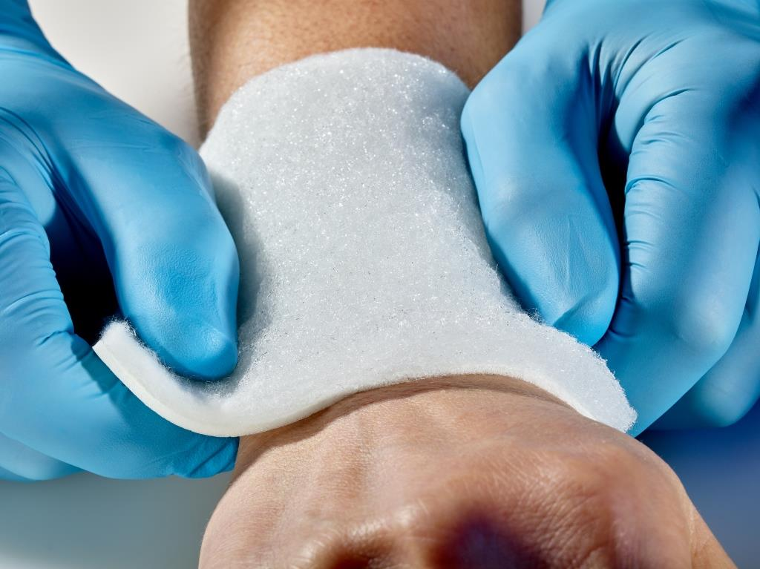
Freudenberg’s PU foam-nonwoven laminate. The combination of foam and nonwoven significantly improves the absorption and retention properties of wound dressings.

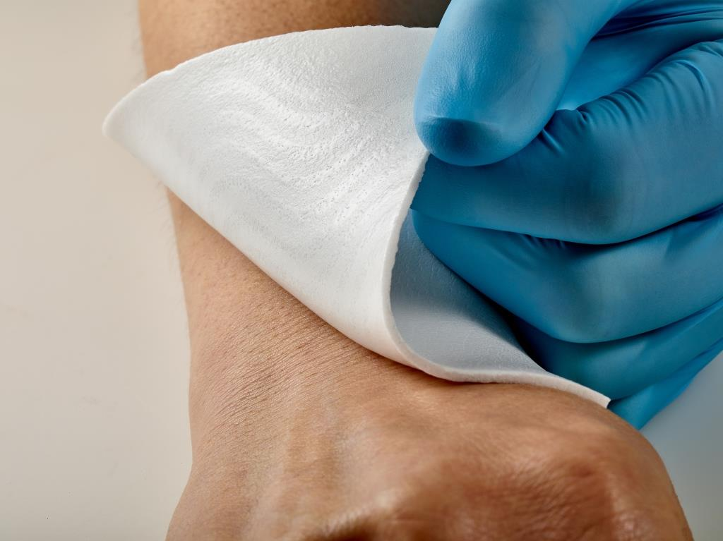
Freudenberg's PU foam with silicone coating helps customers to offer wound dressings that are much more flexible than conventional products and adapt better to the wound bed.

Contact for media enquiries

Freudenberg Performance Materials Holding SE & Co. KG

Holger Steingraeber, Director Global Communications
Höhnerweg 2-4 / 69469 Weinheim / Germany
Phone +49 6201 80 6640
Holger.Steingraeber@freudenberg-pm.com
www.freudenberg-pm.com

Katrin Böttcher, Manager Global Communications
Höhnerweg 2-4 / 69469 Weinheim / Germany
Phone +49 6201 80 5977
Katrin.Boettcher@freudenberg-pm.com
www.freudenberg-pm.com

About Freudenberg Performance Materials
Freudenberg Performance Materials is a leading global manufacturer of innovative technical textiles offering differentiated value propositions to a broad range of markets and applications such as Apparel, Automotive, Building Interiors, Construction, Energy, Hygiene, Medical, Shoe and Leather goods as well as Specialties. In 2017, the company generates sales of more than €935 million and has 25 manufacturing sites in 14 countries and more than 3.700 employees. Freudenberg Performance Materials attaches great importance to social and ecological responsibility. For more information, please visit www.freudenberg-pm.com

The company is a Business Group of Freudenberg Group. In 2017, the Freudenberg Group employed approximately 48,000 people in some 60 countries worldwide and generated sales of more than €9.3 billion. For more information, please visit www.freudenberg.com

