PRESS RELEASE Colmar, 04.09.2018

Evolon® New Generation receives ECARF seal of quality for allergy-friendly products

Evolon® New Generation made by Freudenberg has been awarded the prestigious European seal of quality for anti-mite bedding items. The innovative fabric, which has only recently entered the market, specially meets the stringent testing criteria in terms of filtration performance and sleeping comfort. The seal of the independent European Centre for Allergy Research Foundation (ECARF) aims to help allergic patients select the appropriate goods and services, by certifying the quality of products as well as services according to strict standards.

Evolon® New Generation is made from super-microfilaments that are half the thickness and twice the density of those used in the original Evolon®. This increases its filtration performance significantly.

Furthermore, thanks to a perfect balance of breathability, permeability to water vapor and thermal insulation, Evolon® New Generation provides the best combination of thermo-physiological properties for unparalleled comfort.

Evolon® New Generation’s properties and protection deliver constant performance even after repeated washings at 95°C.

Whereas the original Evolon® was already a perfect solution for the manufacture of anti-mite encasings that help allergy sufferers, Evolon® New Generation now provides a specific solution to make feather-filled pillows and quilts, filtering even tinier allergens and dust particles. With its premium appearance and luxury feel, Evolon® New Generation creates also a new product for anti-allergy top-quality bed linen.

Evolon® New Generation has also been granted the Oeko-Tex mark (standard 100, product class 1, attachment 6), which certifies it is free of harmful substances and suitable for contact with baby skin.

Ten years ago in 2008, the original version of Evolon® had already been the first fabric for anti-mite encasings worldwide to be ECARF-accredited.

Picture
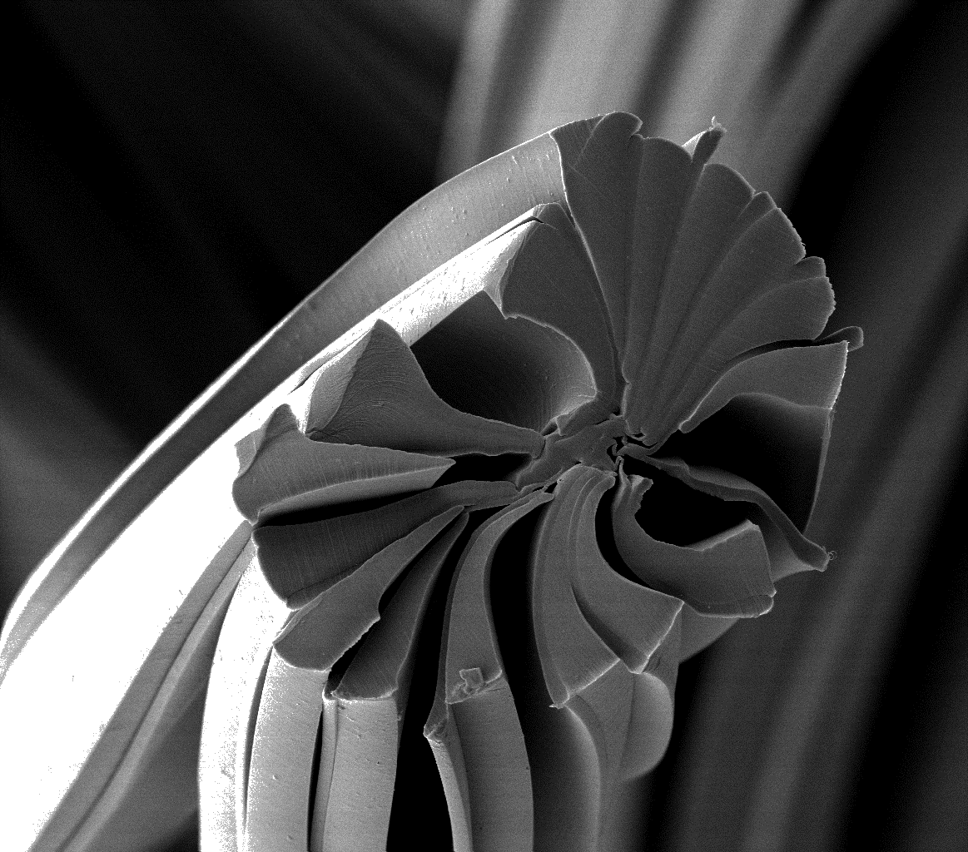

Evolon® New Generation super-microfilaments

Contacts for media enquiries
Freudenberg Performance Materials Holding SE & Co. KG
Holger Steingraeber, Director Global Communications
Höhnerweg 2-4 / 69469 Weinheim / Germany
Ph. +49 6201 80 6640
Holger.Steingraeber@freudenberg-pm.com
www.freudenberg-pm.com

Freudenberg Performance Materials sas
Isabelle Kugler
20 rue Ampère / 68000 Colmar / France
Ph. +33 3 89 20 64 79
Isabelle.kugler@freudenberg-pm.com
www.evolon.com

Please send publication copies to this address

About Freudenberg Performance Materials
Freudenberg Performance Materials is a leading global manufacturer of innovative technical textiles offering differentiated value propositions to a broad range of markets and applications such as Apparel, Automotive, Building Interiors, Construction, Energy, Hygiene, Medical, Shoe and Leather goods as well as Specialties. In 2017, the company generates sales of more than €935 million and has 25 manufacturing sites in 14 countries and more than 3.700 employees. Freudenberg Performance Materials attaches great importance to social and ecological responsibility. For more information, please visit www.freudenberg-pm.com

The company is a Business Group of Freudenberg Group. In 2017, the Freudenberg Group employed approximately 48,000 people in some 60 countries worldwide and generated sales of more than €9.3 billion. For more information, please visit www.freudenberg.com

