PRESS RELEASE

Hydrophilic foam from Freudenberg: more effective wound cleansing and optimal patient comfort

Weinheim, November 7, 2019. Freudenberg Performance Materials will be presenting an innovative hydrophilic foam for wound cleansing for the first time at Compamed in Düsseldorf from November 18 to 21, 2019. The foam enables more effective wound cleansing and increases patient comfort during the cleansing process. Freudenberg will also be showcasing flexible foams for wound dressings with a direct coating of silicone adhesives, which are more effective than conventional foam-silicone constructions. Active worldwide, Freudenberg Performance Materials specializes in pioneering and manufacturing multi-layer material compositions consisting of hydrophilic PU foams and hydroactive nonwovens. Trade fair visitors will find the company at Booth 8B/H01.
Up to now, wound cleansing (debridement) has been performed using fiber-based products or simply cotton gauze. “Our goal was to develop a more efficient product that cleans wounds more effectively and thus has a positive effect on wound healing. Our continuous, close cooperation with wound experts was decisive in being able to achieve this outstanding development result”, commented Dr. Henk R. Randau, General Manager Business Division Healthcare.

The advantages of the new hydrophilic debridement foam for wound cleansing can be easily summarized:
- Ideal for use in wound cavities
Because the foam is soft and flexible throughout, including at the edges, it is ideal for cleansing deep and hard-to-reach wounds.
- Better cleansing results and reduced risk
Thanks to its large pores, the foam also easily picks up fibrin coatings and dried exudate. Furthermore, unlike conventional textile constructions, there is no risk of fibers being left behind in the wound.
- Less pain, greater patient comfort,
Practical tests have shown that the hydrophilic PU foam achieves a better cleansing result, even when used with reduced pressure.
In collaboration with wound experts and scientists, Freudenberg developed its own test method specifically for this product, which substantiates the performance capability of the new debridement foam. The benchmark for the test was a product that offered the best performance achieved so far in the market (gold standard).

Wound dressings: easier to secure and painless removal
Freudenberg will also be exhibiting foams with a direct coating of silicone adhesives at Compamed. The adhesive properties of silicone make it easier to fix the foam bandage and at the same time allow painless removal achieve a wound de-adhesive effect. Wound dressings with a direct coating of silicone adhesives from Freudenberg are significantly more effective than those with conventional coatings. They are much more flexible, adapt better to the wound bed and enable antibacterial agents to act more effectively. This technology also fulfills Freudenberg’s consistent sustainability strategy. By reducing the number of process steps at the wound dressing manufacturer and thereby reducing production complexity, waste is avoided, energy is saved and the supply chain simplified.

Further innovative solutions on the Freudenberg booth
- Components for advanced wound care: superabsorbent nonwovens, nonwoven foam laminates, PU foams
- Components for stoma care: activated carbon filters and nonwoven components for stoma flanges and comfort covers
- Traditional wound care: components for wound dressings, flexible carrier materials and biodegradable nonwovens for wound pads
- Flexible carrier materials for transdermal application systems for active pharmaceutical ingredients (APIs)

Photos:
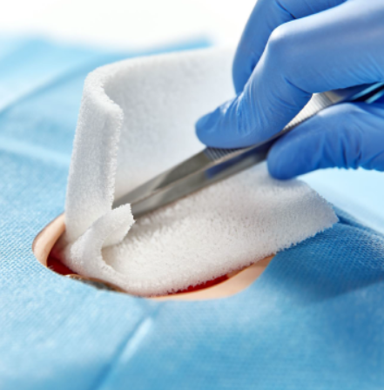
The hydrophilic debridement foam is well suited for cleaning deep wounds and wounds that are difficult to access.

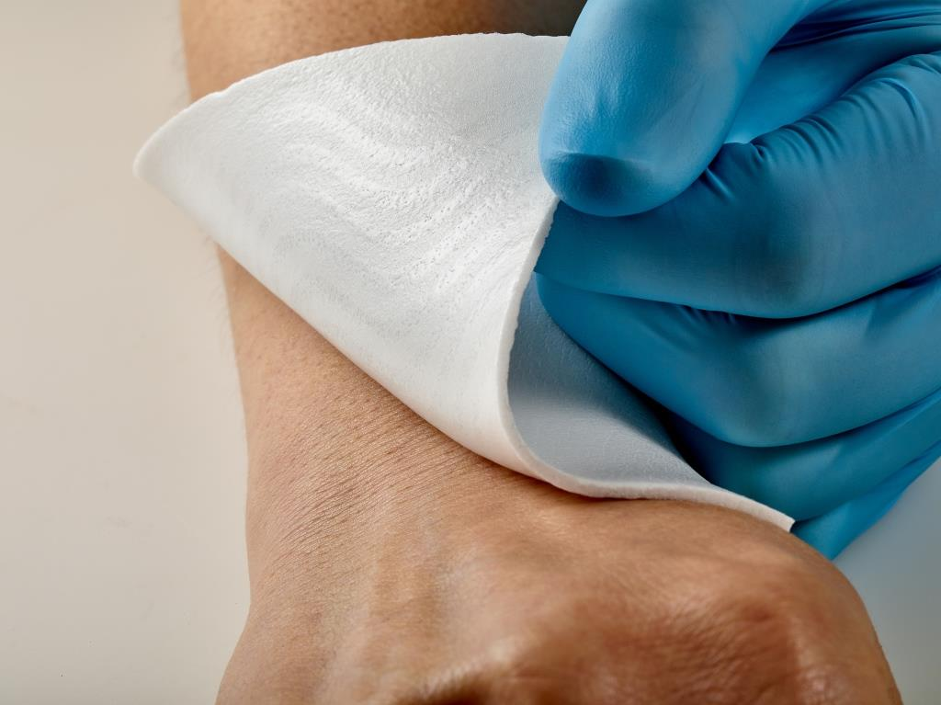
Freudenberg PU foams with directly applied silicone adhesives are more flexible and adapt better to the wound bed.

Contact for media enquiries
Freudenberg Performance Materials Holding SE & Co. KG
Holger Steingraeber  Director Global Communications  Höhnerweg 2-4 / 69469 Weinheim / Germany  Phone +49 6201 80 6640  Holger.Steingraeber@freudenberg-pm.com  www.freudenberg-pm.com | Katrin Böttcher  Manager Global Communications  Phone +49 6201 80 5977  Katrin.Boettcher@freudenberg-pm.com

Please send specimen copies to the above address.

About Freudenberg Performance Materials
Freudenberg Performance Materials is a leading global manufacturer of innovative technical textiles offering differentiated value propositions to a broad range of markets and applications such as apparel, automotive, building materials, energy, filter media, healthcare, hygiene, building Interiors, shoe and leather goods as well as specialties. . In 2018, the company generates sales of more than €920 million and has 23 manufacturing sites in 13 countries and more than 3.600 associates. Freudenberg Performance Materials attaches great importance to social and ecological responsibility. For more information, please visit www.freudenberg-pm.com
The company is a Business Group of Freudenberg Group. In 2018, the Freudenberg Group employed more than 49,000 people in some 60 countries worldwide and generated sales of more than €9.4 billion. For more information, please visit www.freudenberg.com

