PRESS RELEASE

Freudenberg Starts Up New Production Line in Taiwan with Focus on Technology and Sustainability

Weinheim – 2 September 2020. Freudenberg Performance Materials completed the installation of a state-of-the-art spunlaid line in Taiwan and will begin production of nonwovens for diverse markets.

The new production line is the first to feature the latest spunlaid technology developed by Freudenberg. The technology enhances filament distribution for increased material uniformity, which in turn provides customers with ease of processing the nonwovens for a variety of applications. The line also utilizes AI technology to detect variances in the material and automatically adjust uniformity as well as a high-grade IR camera to identify small melt defects. “The expansion of our capabilities underscores our long-term commitment to Asia. We want to continue to support our customers in the automotive and carpet markets with innovative and sustainable solutions that will help them grow,” Dr. Frank Heislitz, CEO of Freudenberg Performance Materials.

In addition to new, proprietary technology, the production line features enhancements to reduce environmental impacts. All parts used in construction were selected based off their energy efficiency to lessen CO2 emissions during operation. The Taiwan site also invested in a new recycling system to recycle all start-up materials as well as scrap materials during normal operations; the recycling line will help the team in their goal to reach zero-waste operations. The spunlaid line will also run partially on solar energy supplied from panels installed on site early last year.

“The new production line will not only allow us to better serve our customers in Asia, but also do so in a sustainable way. We are always researching and implementing new ways to reduce our carbon footprint and that was something we focused on heavily while building up the line – how we could make our operations better for the product and the environment,” Lin Gow Ming, President of Freudenberg Far Eastern Spunweb.

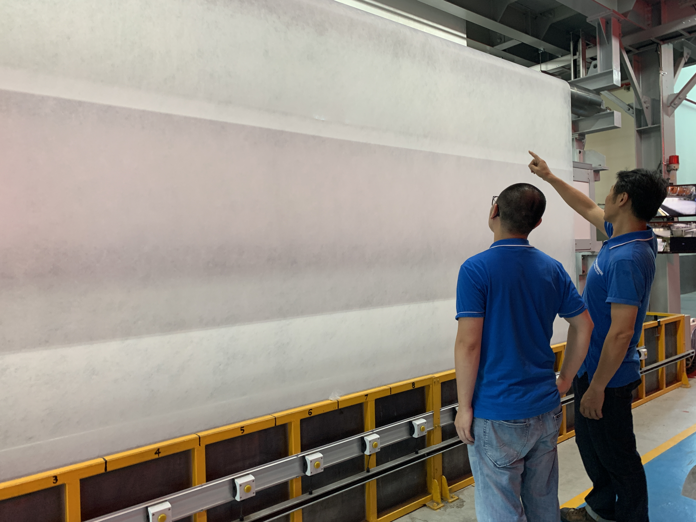

Contacts for media enquiries

Freudenberg Performance Materials Holding SE & Co. KG
Holger Steingraeber, Director Global Communications
Höhnerweg 2-4 / 69469 Weinheim / Germany
Ph. +49 6201 80 6640
Holger.Steingraeber@freudenberg-pm.com
www.freudenberg-pm.com

Please send publication copies to this address

About Freudenberg Performance Materials
Freudenberg Performance Materials is a leading global supplier of innovative technical textiles for a broad range of markets and applications such as apparel, automotive, building interiors, building materials, healthcare, energy, filter media, shoe and leather goods as well as specialties. The Business Group generated sales of 890 million euros in 2019. Today, Freudenberg Performance Materials has 35 production sites around the world in 15 countries and has some 5,500 employees. Freudenberg Performance Materials attaches great importance to social and ecological responsibility as the basis for its business success. For more information, please visit www.freudenberg-pm.com
The company is a Business Group of Freudenberg Group. In 2019, the Freudenberg Group employed more than 49,000 people in some 60 countries worldwide and generated sales of more than €9.4 billion. For more information, please visit www.freudenberg.com

