PRESS RELEASE

Plastic Recycling Awards Europe 2020: Freudenberg Performance Materials named among the finalists
Weinheim, January 21, 2020: Freudenberg Performance Materials (Freudenberg) has been shortlisted for the Plastics Recycling Awards Europe 2020, in the category “Building and Construction Product of the Year” for the project “The virtuous lifecycle of a PET bottle”. Every year, these prestigious awards aim to recognize important achievements and developments in the use of recycled materials, product design and innovative manufacturing within the European plastics recycling industry. The initiative is jointly organized by Plastics Recyclers Europe (PRE) and Crain Communications, which organizes the Plastics Recycling Show Europe.

It is a great honor to be nominated as a finalist for the Plastics Recycling Awards Europe 2020. It reaffirms our global commitment to sustainability,” says Dr. Frank Heislitz, CEO Freudenberg Performance Materials. The history of recycling at Freudenberg dates back to the 1990s. Ever since, the company has been converting post-consumer PET bottles into polyester nonwovens. This material is then used to produce carriers for bituminous waterproofing membranes. At its recycling plants in Novedrate and Pisticci (Italy) and in Colmar (France), Freudenberg currently recycles around 2.5 billion PET bottles every year. Laid end to end, that number would go around the earth 15 times.

“We see plastic as a resource and not as waste. It enables us to do business while at the same time we are protecting the environment. It is an important achievement to be selected among the finalists for this award”, commented Federico Pallini, General Manager Building Materials Division.

By recycling PET bottles, Freudenberg replaces virgin raw materials with recycled polyester of the same quality. This saves natural resources and reduces waste that would otherwise be incinerated or sent to landfill. Furthermore, eliminating the energy consumption associated with producing virgin polyester means fewer CO₂ emissions in the atmosphere.

The award winners will be announced on March 26 during the second day of the Plastics Recycling Show Europe, which is this year being held in Amsterdam.

The Plastics Recycling Awards Europe are open to any organizations and individuals across the continent who are involved in recycling plastic materials.

Further information about the awards can be found here:
https://prseventeurope.com/prse2020/en/page/awards

Photo:
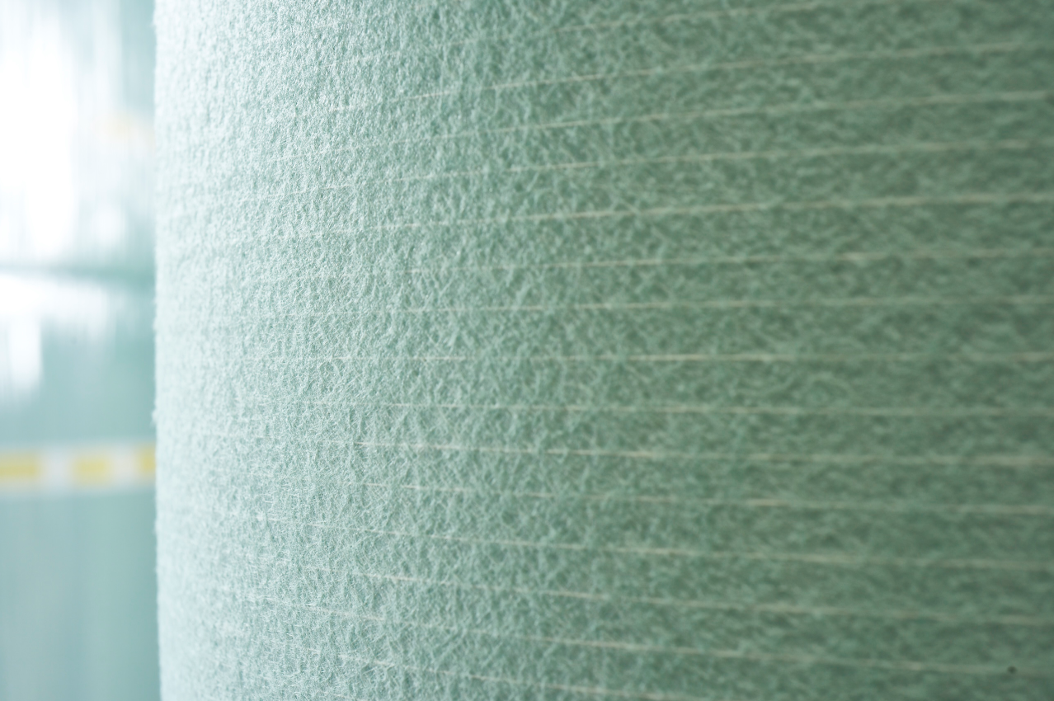
Every year, Freudenberg turns billions of post-consumer PET bottles into recycled polyester nonwovens. This material is then used as carriers for bituminous waterproofing membranes.

Contacts for media enquiries

Freudenberg Performance Materials Holding SE & Co. KG
Holger Steingraeber, Director Global Communications
Höhnerweg 2-4 / 69469 Weinheim / Germany
Ph. +49 6201 80 6640
Holger.Steingraeber@freudenberg-pm.com
www.freudenberg-pm.com

Please send publication copies to this address.

About Freudenberg Performance Materials
Freudenberg Performance Materials is a leading global manufacturer of innovative technical textiles offering differentiated value propositions to a broad range of markets and applications such as apparel, automotive, building materials, energy, filter media, healthcare, hygiene, building interiors, shoe and leather goods as well as specialties. In 2018, the company generated sales of more than €920 million, has 23 manufacturing sites in 13 countries and more than 3.600 associates. Freudenberg Performance Materials attaches great importance to social and ecological responsibility.
For more information, please visit www.freudenberg-pm.com
The company is a Business Group of Freudenberg Group. In 2018, the Freudenberg Group employed more than 49,000 people in some 60 countries worldwide and generated sales of more than €9.4 billion. For more information, please visit www.freudenberg.com

