PRESS RELEASE

Surgical Masks by Freudenberg receive 510(k) clearance from the FDA

Durham, NC – 9 February 2021. ASTM Level 3 surgical masks manufactured by Freudenberg Performance Materials recently received 510(k) clearance from the US Food and Drug Administration (FDA). The surgical masks are intended for use by healthcare personnel to protect both the patient and themselves from transfer of microorganisms, body fluids and particulate material. The face masks are intended for use in infection control practices to reduce the potential exposure to blood and body fluids.

For the US market, Freudenberg Performance Materials is now providing FDA cleared surgical masks meeting the Level 3 standard of the American Society of Testing and Materials (ASTM). The ASTM Level 3 surgical mask is for use in conditions where there is a high risk of fluid and spray of aerosol transmission, such as operating procedures. The masks are a single use, disposable device provided non-sterile.

Surgical masks by Freudenberg were tested for performance in five areas: fluid resistance, differential pressure, particulate efficiency, bacterial filtration efficiency and flammability. Upon completion of testing, the surgical masks consistently met ASTM Level 3 criteria in all five performance test areas. Bacterial and particle filtration efficiency test results were greater than 99 percent.

“This was a great accomplishment for our team. It is a milestone that supports our commitment to continue manufacturing local. Meeting the ASTM Level 3 standard helps us in our goal to not only keep our healthcare workers safe, but also ensure they have a steady, reliable PPE supply so the shortages that happened at the beginning of the pandemic don’t happen again,” Alicen Pittenger, Head of Sales – North America – Global Healthcare Division, Freudenberg.

The Durham, NC site of Freudenberg Performance Materials began mask production in 2020 in response to the COVID-19 pandemic. Working closely with local partners, Freudenberg is also aiming to prevent future PPE supply shortages by establishing long-term face mask production for the US market. The site manufactures surgical masks and community masks and is pursuing NIOSH N95 respirator certification.

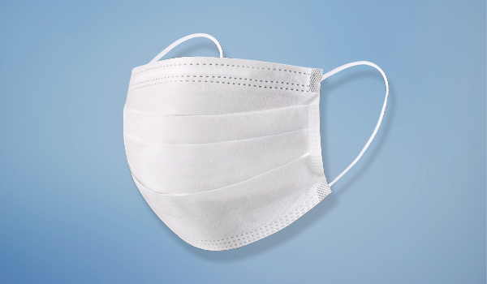

Contacts for media enquiries

Freudenberg Performance Materials LP
Rachel Patiño, Communications & Marketing Manager – North America
3500 Industrial Drive / Durham, NC 27704 / USA
+1 828 772 4760
rachel.patino@freudenberg-pm.com

Freudenberg Performance Materials Holding SE & Co. KG
Holger Steingraeber, Director Global Communications
Höhnerweg 2-4 / 69469 Weinheim / Germany
Ph. +49 6201 80 6640
Holger.Steingraeber@freudenberg-pm.com
www.freudenberg-pm.com

Please send publication copies to this address

About Freudenberg Performance Materials
Freudenberg Performance Materials is a leading global supplier of innovative technical textiles for a broad range of markets and applications such as apparel, automotive, building interiors, building materials, healthcare, energy, filter media, shoe and leather goods as well as specialties. The Business Group generated sales of 890 million euros in 2019. Today, Freudenberg Performance Materials has 35 production sites around the world in 15 countries and has some 5,500 employees. Freudenberg Performance Materials attaches great importance to social and ecological responsibility as the basis for its business success. For more information, please visit www.freudenberg-pm.com
The company is a Business Group of Freudenberg Group. In 2019, the Freudenberg Group employed more than 49,000 people in some 60 countries worldwide and generated sales of more than €9.4 billion. For more information, please visit www.freudenberg.com

