PRESS RELEASE

Construction of the competence center for apparel interlinings in Italy starts on schedule

Weinheim, December 13, 2021. Freudenberg Performance Materials Apparel Europe started construction work on its competence center for finishing and coating base material for the apparel industry at its site in Sant´Omero as scheduled in December. Further processing of base material is to begin in Italy in early 2023. The Weinheim site will then become the competence center for interlining base material.

In January 2021, Freudenberg Performance Materials Apparel Europe (Freudenberg) announced plans to set up two competence centers. In future, the company will concentrate on manufacturing base material for interlinings at the Weinheim location. Base material finishing and coating is to be bundled at Sant´Omero. For this purpose, production plant will be relocated from Weinheim to Sant´Omero and recommissioned in a newly-built production hall. “Thanks to the outstanding work of our employees, this complex project is running to schedule despite the corona pandemic, and we have now reached this important milestone,” Dr. Hannah Koeppen, General Manager Freudenberg Performance Materials Apparel Europe, said. The traditional groundbreaking ceremony with senior representatives from local authorities and Freudenberg management was cancelled due to the high number of coronavirus cases in the area.

Photo and caption
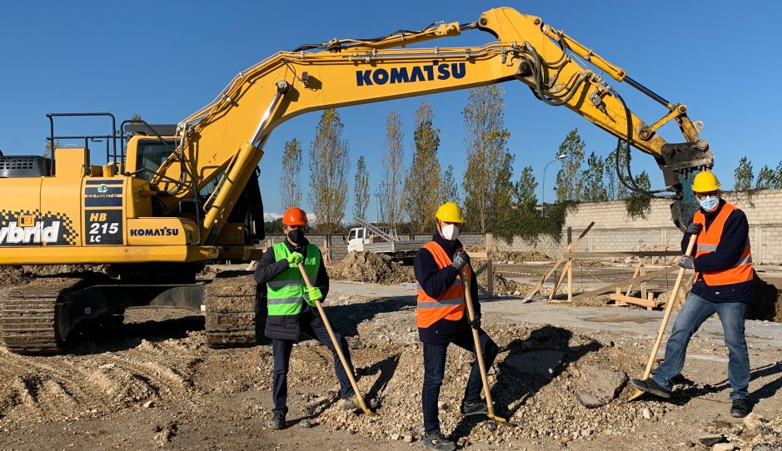
The official ground-breaking ceremony had to be called off due to Corona. Instead, project participants from the Freudenberg site in Sant'Omero came together in a small circle. From left: Pietro Traini, Civil Engineer, Dr. Bruno Brandozzi, Manager HSE and Compliance, and Dr. Christian Cavaletti, Operations Manager Sant ́Omero site.

Contact for media enquiries
Freudenberg Performance Materials Holding SE & Co. KG
Holger Steingraeber, SVP Global Marketing & Communications
Höhnerweg 2-4 / 69469 Weinheim / Germany
Tel. +49 6201 80 6503
Holger.Steingraeber@freudenberg-pm.com
www.freudenberg-pm.com

Katrin Böttcher, Manager Global Media Relations
Höhnerweg 2-4 / 69469 Weinheim / Germany
Tel. +49 6201 80 5977
Katrin.Boettcher@freudenberg-pm.com
www.freudenberg-pm.com

About Freudenberg Performance Materials
Freudenberg Performance Materials is a leading global supplier of innovative technical textiles for a broad range of markets and applications such as apparel, automotive, building interiors, building materials, healthcare, energy, filter media, shoe and leather goods as well as specialties. In 2020, the company generated sales of more than €1 billion, had 33 production sites in 14 countries around the world and had some 5.000 employees. Freudenberg Performance Materials attaches great importance to social and ecological responsibility as the basis for its business success. For more information, please visit www.freudenberg-pm.com
The company is a Business Group of Freudenberg Group. In 2020, the Freudenberg Group employed more than 48,000 people in some 60 countries worldwide and generated sales of more than €8.8 billion. For more information, please visit www.freudenberg.com

