PRESS RELEASE

With MADE IN GREEN by OEKO-TEX®, Evolon® receives certification for sustainable production and safe products

Colmar (France), September 21st, 2021. Evolon® fabrics are well-known for combining high performance technical properties with numerous ecological benefits in many durable applications. Furthermore, according to the independent OEKO-TEX® institute, Evolon® fabrics also meet the most stringent requirements in terms of sustainability and health and safety. Freudenberg in Colmar, France, recently received the STeP by OEKO-TEX® label for Evolon®. The fabric was also granted the MADE IN GREEN by OEKO-TEX® label. This confirms the brand’s commitment to sustainable practices and products.

Certificates awarded by the independent OEKO-TEX® institute are highly respected and trusted by the textile industry because they are 100 percent transparent, 100 percent independent, 100 percent textile. For manufacturers, they are confirmation of ecologically and socially responsible production and products – a quality characteristic that plays a growing role in purchasing decisions of companies as well as for end-users.

By awarding the STeP (Sustainable Leather & Textile Production) label, the OEKO-TEX® institute recently certified environmentally friendly production processes, a high level of health and safety and socially responsible working conditions at the Freudenberg site in Colmar. The company scored top marks and reached the highest grade of certification, namely Level 3, for “exemplary implementation of best practices”.

“Evolon® fabrics have already held the STANDARD 100 by OEKO-TEX® label for more than twenty years. This is one of the world’s best-known certificates confirming that textiles have been tested for harmful substances. Here too, Evolon® meets the most stringent requirements, and is ranked in product class I, which stands for suitability with baby skin contact”, explains Achraf Khedimi, Head of Global Sales Evolon.

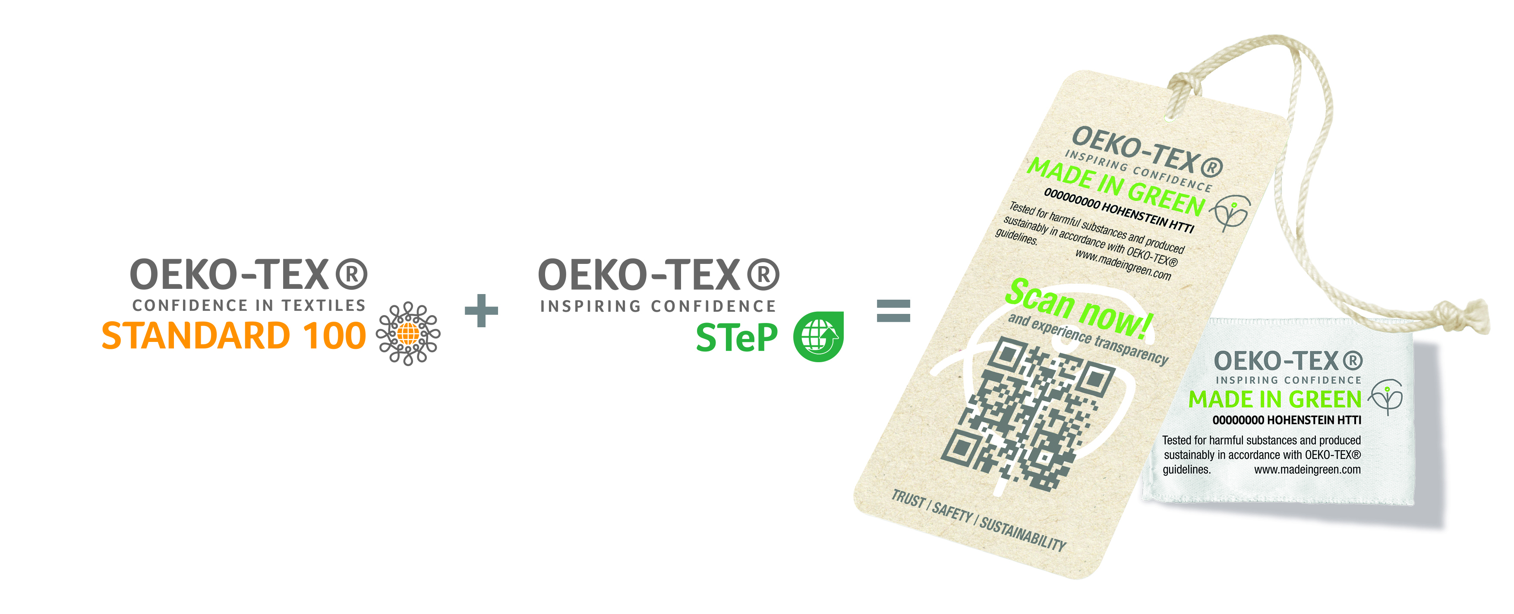
As a result of the combination of STeP and STANDARD 100 certificates, Evolon® meets all the requirements for the coveted MADE IN GREEN by OEKO-TEX® label. This proves that a product has been tested for harmful substances and manufactured using sustainable processes under socially responsible working conditions. The certificate also confirms the complete traceability of all materials and a transparent supply chain, and thus offers consumers the highest level of safety.

Last but not least, compliance with DETOX TO ZERO by OEKO-TEX® criteria is fully achieved as part of the SteP certification. This specifically covers chemicals management and wastewater quality, following an initiative of Greenpeace which aims at eliminating harmful substances in the textile industry.

Contacts for media enquiries
Freudenberg Performance Materials Holding SE & Co. KG
Holger Steingraeber, Senior Vice President Global Marketing & Communications
Höhnerweg 2-4 / 69469 Weinheim / Germany
Tel. +49 6201 80 6503
Holger.Steingraeber@freudenberg-pm.com
www.freudenberg-pm.com

Katrin Böttcher, Manager Global Marketing & Communications
Höhnerweg 2-4 / 69469 Weinheim / Germany
Tel. +49 6201 80 5977
Katrin.Boettcher@freudenberg-pm.com
www.freudenberg-pm.com

About Freudenberg Performance Materials
Freudenberg Performance Materials is a leading global supplier of innovative technical textiles for a broad range of markets and applications such as apparel, automotive, building interiors, building materials, healthcare, energy, filter media, shoe and leather goods as well as specialties. In 2020, the company generated sales of more than €1 billion, had 33 production sites in 14 countries around the world and had some 5.000 employees. Freudenberg Performance Materials attaches great importance to social and ecological responsibility as the basis for its business success. For more information, please visit www.freudenberg-pm.com
The company is a Business Group of Freudenberg Group. In 2020, the Freudenberg Group employed more than 48,000 people in some 60 countries worldwide and generated sales of more than €8.8 billion. For more information, please visit www.freudenberg.com / www.evolon.com

