PRESS RELEASE

techtextil 2022:
“Freudenberg Experts meet Sustainability”

Weinheim, May 10, 2022. Following their merger, Freudenberg Performance Materials, Low & Bonar, Mehler Texnologies® and Filc will be presenting their innovative solutions at a joint stand for the first time at this year’s techtextil exhibition in Frankfurt. The focus is on sustainability. Among the highlights are Evolon® RE, a microfilament textile for a wide variety of applications and markets, FILFLEX, a sustainable padding material for car seat covers, and the truck tarpaulin POLYMAR® 8556 ECO CF. Customers will find the world's leading manufacturer of technical textiles at Stand C51 in Hall 12.1.

Evolon® textiles made from recycled PET
With Evolon® RE, Freudenberg Performance Materials is presenting an even more sustainable version of its high-performance microfilament textiles. Evolon® RE is manufactured from an average of 70% recycled polyester, which the company makes by cycling post-consumer PET bottles in-house. Evolon® RE products are available for various applications such as technical packaging, in weights currently ranging from 80g/sqm to 300g/sqm. For high-tech wiping, lightweight Evolon® RE is now available starting from 30g/sqm. The material meets the needs of cleaning specialists for more sustainable wiping solutions. Evolon® RE offers the same high quality and material performance as all other Evolon® textiles.

Tarpaulins made from recycled raw materials presented by Mehler Texnologies®
When it comes to tarpaulins on trucks, both protection of the transport cargo and advertising for the transport company place high demands on the material. Mehler Texnologies® tarpaulin material ranks among the premium products for truck tarpaulins. The company is a pioneer in sustainable development and is showcasing POLYMAR® 8556 ECO CF. This unique material has a 25% share of recycled raw materials in the coating mass. In addition, the material is made with 100% R-PES yarns. The input materials undergo a complex separation and filtering process.

Sustainable padding material for automotive and furniture seat covers presented by FILC
FILFLEX is a soft and flexible padding layer made from nonwovens for automotive and furniture seat covers. It prevents leather from creasing and improves the dimensional stability of the seat covers. In terms of sustainability, its benefit is its 100% PET composition, making FILFLEX easy to recycle. FILFLEX offers customers easier handling during sewing and the seat covering process. End users benefit from the high seating comfort.

Picures:
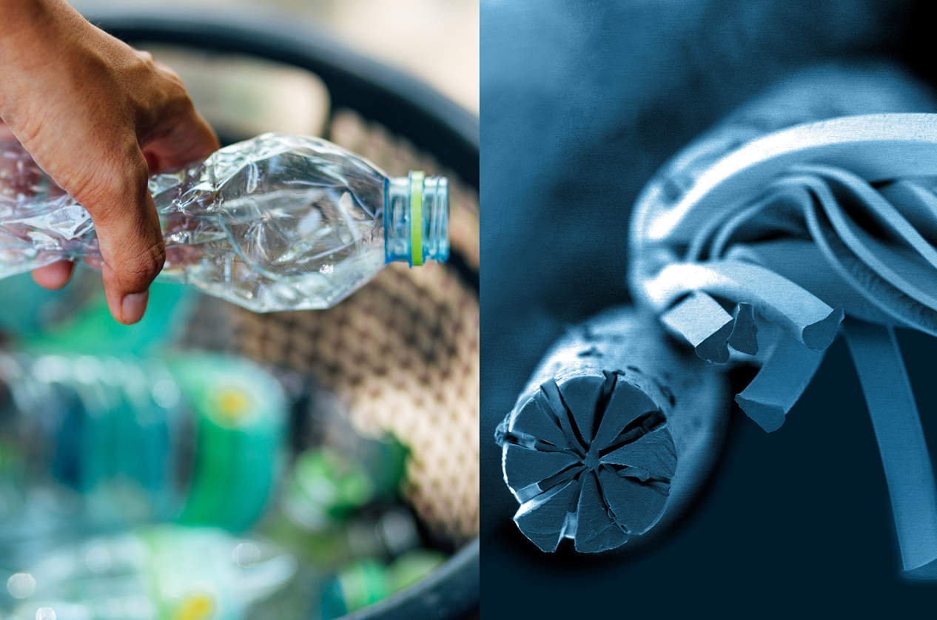

Evolon ® RE made from plastic bottles.

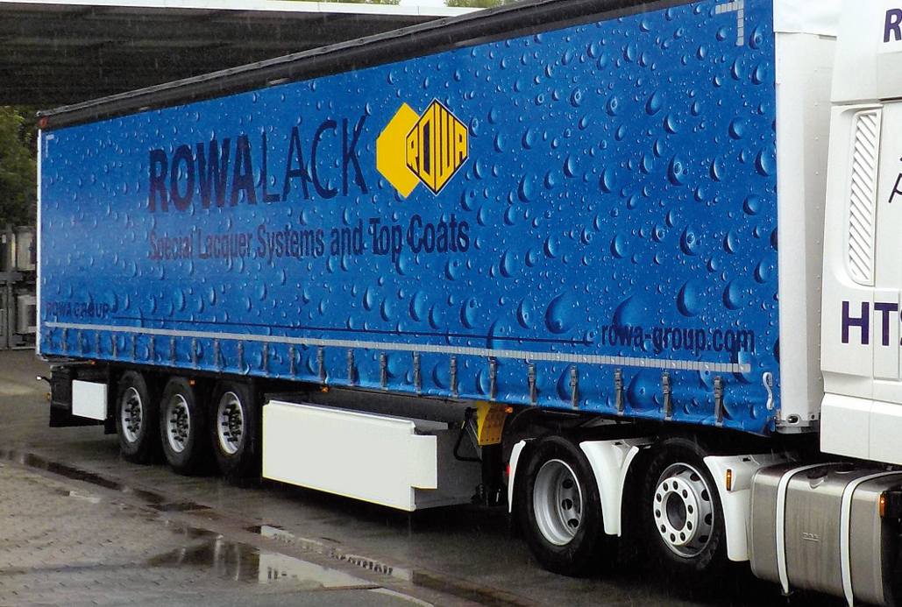
Sustainable tarpaulin for trucks by Mehler Texnologies®

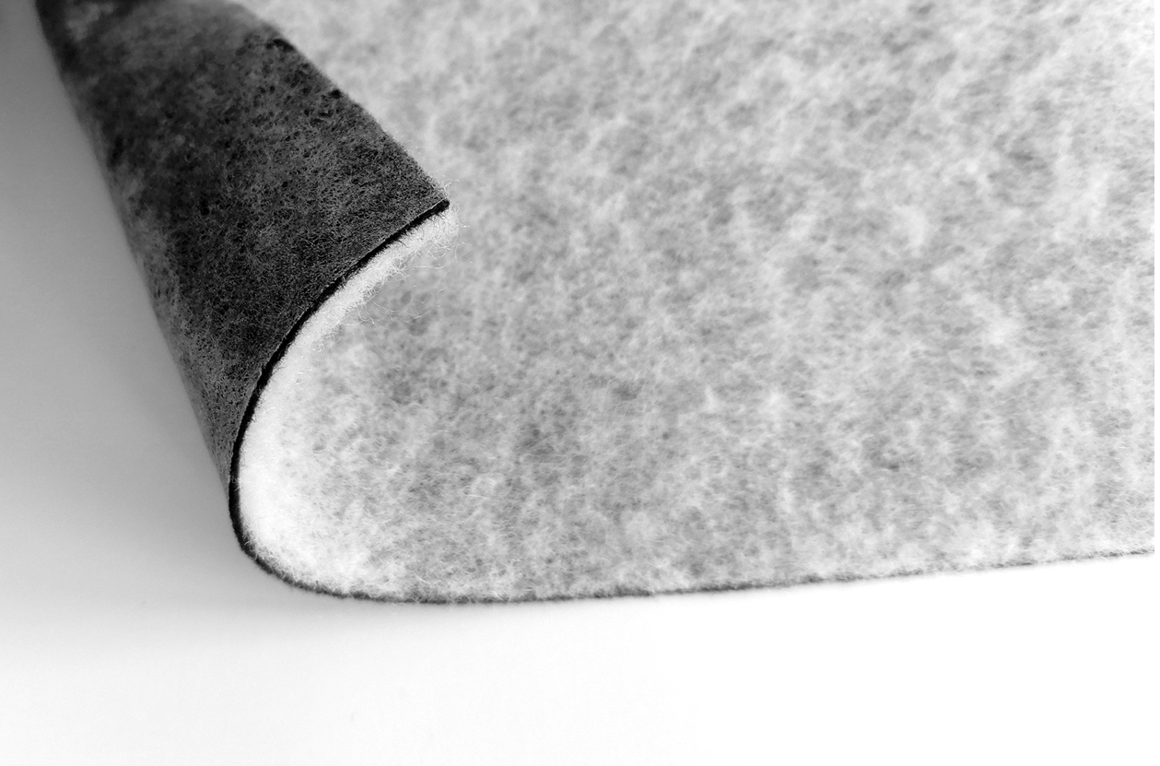
Sustainable seat covers padding material by FILC

Contacts for media enquiries
Freudenberg Performance Materials Holding SE & Co. KG
Holger Steingraeber, SVP Global Marketing & Communications
Höhnerweg 2-4 / 69469 Weinheim / Germany
Phone +49 6201 80 6503
Holger.Steingraeber@freudenberg-pm.com
www.freudenberg-pm.com

Katrin Böttcher, Manager Global Media Relations
Höhnerweg 2-4 / 69469 Weinheim / Germany
Phone +49 6201 80 5977
Katrin.Boettcher@freudenberg-pm.com
www.freudenberg-pm.com

About Freudenberg Performance Materials
Freudenberg Performance Materials is a leading global supplier of innovative technical textiles for a broad range of markets and applications such as apparel, automotive, building interiors, building materials, healthcare, energy, filter media, shoe and leather goods as well as specialties. In 2021, the company generated sales of more than €1.3 billion, had 33 production sites in 14 countries around the world and had some 5.000 employees. Freudenberg Performance Materials attaches great importance to social and ecological responsibility as the basis for its business success. For more information, please visit www.freudenberg-pm.com
In 2021, the Freudenberg Group employed some 50,000 people in around 60 countries worldwide and generated sales of more than €10 billion. For more information, please visit www.freudenberg.com.

