**PRESS RELEASE**

**Lineapelle September 2023:**

**Freudenberg unveils sustainable microfiber solution made in the EU for artificial leather applications**

**Weinheim/Germany, July 18, 2023.** **Freudenberg Performance Materials (Freudenberg) will be presenting new applications for its European environmentally-friendly Evolon® microfiber technology for Fall/Winter 24/25 fashion and leather goods collections at the international trade fair for the leather industry. For the first time, these include innovative solutions for artificial leather applications suitable for the shoe, furniture and automotive industries. Freudenberg will be welcoming visitors to Booth D02-D04 in Hall 9 of the trade fair in Milan from September 19-21.**

**Evolon® sustainable microfiber coating substrates**

Evolon® microfiber fabrics are ideal coating substrates for artificial leather applications in the shoe, furniture and car industries. They are particularly suitable as a carrier material for PU and PVC coatings. Evolon® microfiber materials have non-fraying edges, which makes converting easier and quicker. They contain 80% recycled PET from Freudenberg’s in-house bottle recycling plant. Furthermore, they are manufactured with no solvent and no chemical binder in the company’s Evolon® plant located in Colmar, France. The plant is accredited according to OEKO-TEX STeP sustainability manufacturing certification and the DETOX TO ZERO criteria. European manufacturing offers logistic benefits to European customers through shorter supply chain and transport routes.

**Reinforcement material for leather goods**

Manufacturers of leather goods also benefit from Evolon® microfiber when they use it as a reinforcement material for original leather. It is drapable and soft and provides optimal shaping support for leather. In addition, Evolon® materials offer important sustainability advantages for the manufacturing of luxury leather bags, such as being 100% made in Europe, eco-friendly and socially-responsible production, and the use of recycled raw materials.

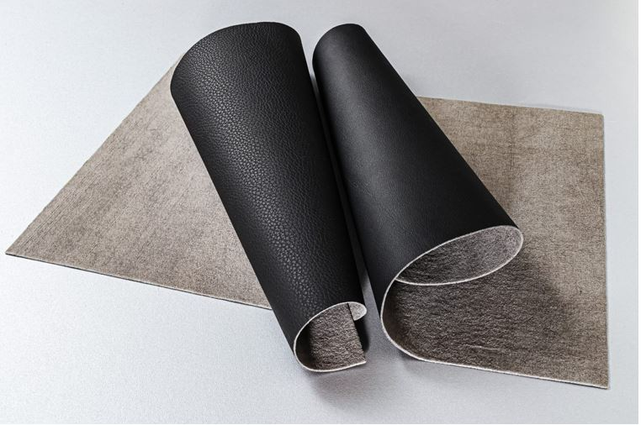

Photo: Evolon® sustainable microfiber coating substrate for artificial leather.

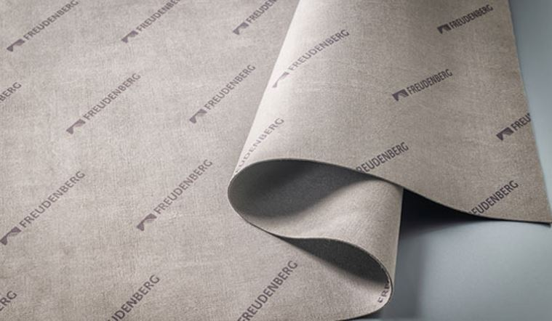

Photo: Evolon® sustainable microfiber reinforcement layer for leather goods.

Contact for media inquiries

Freudenberg Performance Materials Holding GmbH

Holger Steingraeber, SVP Global Marketing & Communications

Höhnerweg 2-4 / 69469 Weinheim / Germany

Phone +49 6201 7107 007

Holger.Steingraeber@freudenberg-pm.com

www.freudenberg-pm.com

Katrin Böttcher, Manager Global Media Relations

Höhnerweg 2-4 / 69469 Weinheim / Germany

Phone +49 6201 7107 014

Katrin.Boettcher@freudenberg-pm.com

www.freudenberg-pm.com

About Freudenberg Performance Materials

Freudenberg Performance Materials is a leading global supplier of innovative technical textiles for a broad range of markets and applications such as apparel, automotive, building interiors, building materials, healthcare, energy, filter media, shoe and leather goods as well as specialties. In 2022, the company generated sales of some €1.6 billion, had 32 production sites in 14 countries around the world and had more than 5.000 employees. Freudenberg Performance Materials attaches great importance to social and ecological responsibility as the basis for its business success. For more information, please visit www.freudenberg-pm.com

In 2022, the Freudenberg Group employed more than 51,000 people in around 60 countries worldwide and generated sales of more than €11,7 billion. For more information, please visit www.freudenberg.com.