**PRESS RELEASE**

**Freudenberg extends ECO range for sustainable carpet backings**

**Weinheim, Germany, October 5, 2023. Freudenberg Performance Materials (Freudenberg) is extending its recently-introduced ECO range of sustainable nonwoven carpet backings: Lutradur ECO-R** **and Colback ECO-R** **backings contain high percentages of recycled raw materials. With its ECO portfolio Freudenberg supports carpet manufacturers in their transition towards an increasingly sustainable product offering.**

**ECO-R products**

Freudenberg’s spunbond nonwoven primary and secondary carpet backings contribute to manufacturers’ easy and efficient production processes as well as to high-performance end products. The company is now extending its ECO range in Europe with Colback ECO-R and Lutradur ECO-R backings that contain a recycled content of between 51 and 90 %. Replacing virgin raw materials with recycled polyester saves on natural resources and improves the carbon footprint of end products. The ECO-R backings are specifically suitable for carpet tiles, broadloom, dust control mats and automotive option mats.

**ECO-RE products**

The company launched its ECO range for sustainable primary backings earlier this year with the introduction of the ECO-RE resource-efficient backings that use less raw materials and support end product recyclability. To achieve this, Freudenberg R&D teams further developed the company’s proprietary yarn production technology allowing for extremely thin filaments.

**ECO range**

“With the extended ECO range, Freudenberg now offers a variety of different solutions supporting carpet manufacturers in making sustainable choices to suit their ambitions and processes”, says Albert Hammerschmied, Director for EMEA carpet business with responsibility for New Business Development and Sustainability. “Freudenberg is a long-term supplier to the industry with a strong history of developing tailored solutions for and with our industry partners. The continuous development of backings with recycled content is one result of these efforts.”

**Further CO2 savings**

Freudenberg manufactures carpet backings with recycled content in Europe, North America and China, allowing customers within the world regions to further optimize their CO2 footprint thanks to short transportation routes.

**Picture:**

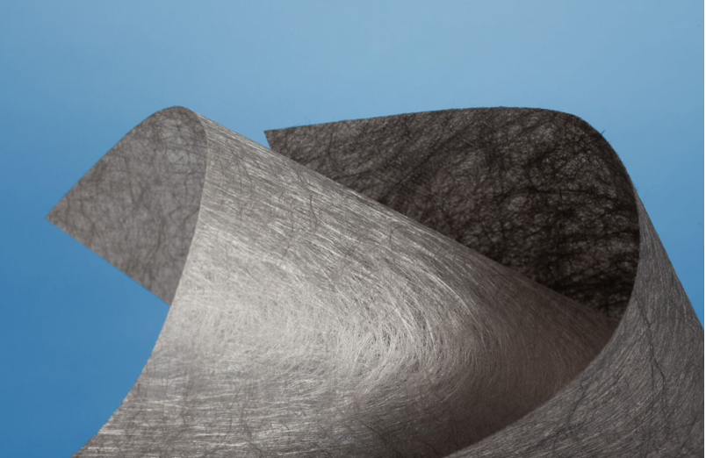

*Freudenberg´s Colback ECO-R and Lutradur ECO-R backings contain a recycled content of between 51 and 90 %.*

**Contact for media inquiries**

Freudenberg Performance Materials Holding SE & Co. KG

Holger Steingraeber, SVP Global Marketing & Communications

Höhnerweg 2-4 / 69469 Weinheim / Germany

Phone +49 6201 7107 007

Holger.Steingraeber@freudenberg-pm.com

www.freudenberg-pm.com

Katrin Böttcher, Manager Global Media Relations

Höhnerweg 2-4 / 69469 Weinheim / Germany

Phone +49 6201 7107 014

Katrin.Boettcher@freudenberg-pm.com

www.freudenberg-pm.com

About Freudenberg Performance Materials

Freudenberg Performance Materials is a leading global supplier of innovative technical textiles for a broad range of markets and applications such as apparel, automotive, building interiors, building materials, healthcare, energy, filter media, shoe and leather goods as well as specialties. In 2022, the company generated sales of some €1.6 billion, had 32 production sites in 14 countries around the world and had more than 5.000 employees. Freudenberg Performance Materials attaches great importance to social and ecological responsibility as the basis for its business success. For more information, please visit [www.freudenberg-pm.com](http://www.freudenberg-pm.com/)

In 2022, the Freudenberg Group employed more than 51,000 people in around 60 countries worldwide and generated sales of more than €11,7 billion. For more information, please visit [www.freudenberg.com](https://eur02.safelinks.protection.outlook.com/?url=http%3A%2F%2Fwww.freudenberg.com%2F&data=05%7C01%7CKatrin.Boettcher%40freudenberg-pm.com%7C626c59786cf34fe9190208db30519ac7%7Cc7b0778106f341d7b40f5b2de1018509%7C0%7C0%7C638156899268415847%7CUnknown%7CTWFpbGZsb3d8eyJWIjoiMC4wLjAwMDAiLCJQIjoiV2luMzIiLCJBTiI6Ik1haWwiLCJXVCI6Mn0%3D%7C3000%7C%7C%7C&sdata=RBXz42KngWFWDAphKaNeVrRIyZsafcGzSGAS1GC%2FEOI%3D&reserved=0).