PRESS RELEASE

New technical textiles website for South America

Weinheim, Germany, November 29, 2023. Freudenberg Performance Materials is launching americadosul.freudenberg-pm.com – a website dedicated to the South American markets. For decision makers in the apparel, shoe and other technical industries, information on the regional presence of one of the world-leading suppliers and its portfolio of technical textiles and textile technologies is now just a few clicks away.

Every market served by Freudenberg Performance Materials in the South America region has a presence on the new website americadosul.freudenberg-pm.com with a dedicated page detailing all products and applications. Players in the apparel industry, for example, can find out more about the company’s interlining solutions for fashion, activewear and workwear. Shoe and leather goods manufacturers will also find useful information about the company’s capabilities in their sectors. The website also presents other applications for technical nonwovens, such as automotive interior and e-mobility solutions, cable tapes and battery separators for the energy market, nonwovens for fiber-reinforced composites, weed control, etc.

Information about technologies
Another important section of the website provides in-depth descriptions of the materials and technologies offered by the company, including nonwovens, wovens, knits, composites, as well as Dripstop® condensation control technology and Evolon® microfilament textile technology.

Contacting the South American team is easy
Contacting Freudenberg Performance Materials through the new website is quick and easy, either by using the contact form, or by reaching out to the local offices in Brazil and Colombia; full contact details are available on a dedicated page. The offices in Brazil and Colombia serve customers all over South America.

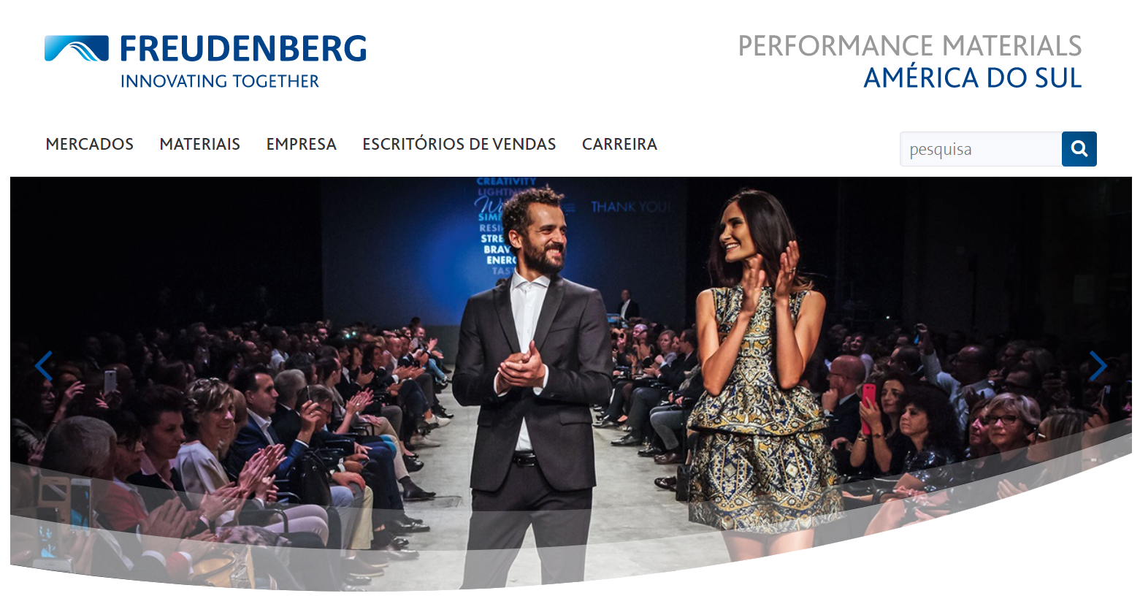Picture: Dedicated to the South American markets: americadosul.freudenberg-pm.com

Contact for media inquiries
Freudenberg Performance Materials Holding GmbH
Holger Steingraeber, SVP Global Marketing & Communications
Höhnerweg 2-4 / 69469 Weinheim / Germany
Phone +49 6201 7107 007
Holger.Steingraeber@freudenberg-pm.com
www.freudenberg-pm.com

Katrin Böttcher, Manager Global Media Relations
Höhnerweg 2-4 / 69469 Weinheim / Germany
Phone +49 6201 7107 014
Katrin.Boettcher@freudenberg-pm.com
www.freudenberg-pm.com

About Freudenberg Performance Materials
Freudenberg Performance Materials is a leading global supplier of innovative technical textiles for a broad range of markets and applications such as apparel, automotive, building interiors, building materials, healthcare, energy, filter media, shoe and leather goods as well as specialties. In 2022, the company generated sales of some €1.6 billion, had 32 production sites in 14 countries around the world and had more than 5.000 employees. Freudenberg Performance Materials attaches great importance to social and ecological responsibility as the basis for its business success. For more information, please visit www.freudenberg-pm.com

In 2022, the Freudenberg Group employed more than 51,000 people in around 60 countries worldwide and generated sales of more than €11,7 billion. For more information, please visit www.freudenberg.com.

