PRESS RELEASE

New fully synthetic wetlaid nonwovens made in Europe for filtration and other applications

Weinheim, February 29, 2024. Freudenberg Performance Materials (Freudenberg) is unveiling a new 100 percent synthetic wetlaid nonwoven product line made in Germany. The new materials can be manufactured from various types of polymer-based fibers, including ultra-fine micro-fibers. These unique wetlaid materials from Freudenberg are designed for use in filtration applications as well as other industrial applications. This product line rounds off the wide range of wetlaid nonwoven capabilities from the leading manufacturer of high-performance materials.

Customers in the filtration business can use Freudenberg’s new fully synthetic wetlaid nonwovens in both liquid and air filtration. Applications include reverse osmosis membrane support, support for nanofibers or PTFE membranes as well as oil filtration media. The new materials are suited to use in the building & construction industry or the composites industry.
For filtration applications, the new fully synthetic wetlaid nonwovens are marketed under the Filtura® brand.

Versatile and flexible manufacturing
Freudenberg’s fully synthetic wetlaid nonwovens can be made of polyester, polyolefin, polyamide and polyvinyl alcohol (PVA), using staple fibers of up to 12mm fiber length and microfibers as fine as 0.04dtex. In terms of weight, the product range spans weights of between 8g/m² and 250g/m². Freudenberg’s flexible wetlaid manufacturing line has the capability to combine various thermal and chemical bonding technologies. The materials have high precision in weight and thickness as well as a defined pore size and high porosity.
Wide range of wetlaid capabilities for various applications
In addition to its fully synthetic range, Freudenberg can also incorporate glass fibers, viscose and cellulose. General industry applications for Freudenberg wetlaid nonwovens are surfacing veils for glass-fiber reinforced plastics, compostable desiccant bags, battery separators, acoustics, heatshields, and apparel applications such as embroidery substrates.

Photos:
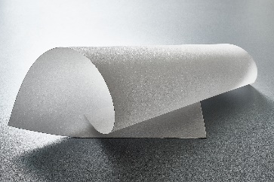
Freudenberg’s fully synthetic wetlaid material for reverse osmosis membranes

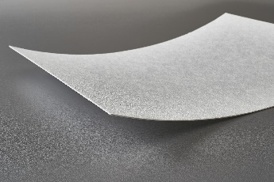
Freudenberg’s fully synthetic wetlaid material for engine oil filters

Contacts for media inquiries
Freudenberg Performance Materials Holding GmbH
Holger Steingraeber, SVP Global Marketing & Communications
Höhnerweg 2-4 / 69469 Weinheim / Germany
Tel.: +49 6201 7107 007
Holger.Steingraeber@freudenberg-pm.com
www.freudenberg-pm.com

Katrin Böttcher, Manager Global Media Relations
Höhnerweg 2-4 / 69469 Weinheim / Germany
Tel.: +49 6201 7107 014
Katrin.Boettcher@freudenberg-pm.com
www.freudenberg-pm.com

About Freudenberg Performance Materials
Freudenberg Performance Materials is a leading global supplier of innovative technical textiles for a broad range of markets and applications such as apparel, automotive, building interiors, building materials, healthcare, energy, filter media, shoe and leather goods as well as specialties. In 2022, the company generated sales of some €1.6 billion, had 32 production sites in 14 countries around the world and had more than 5.000 employees. Freudenberg Performance Materials attaches great importance to social and ecological responsibility as the basis for its business success. For more information, please visit
www.freudenberg-pm.com

In 2022, the Freudenberg Group employed more than 51,000 people in around 60 countries worldwide and generated sales of more than €11,7 billion. For more information, please visit www.freudenberg.com.

