Press Release

Freudenberg’s Sant’Omero site implements ZDHC

Weinheim, March 12th, 2024. Freudenberg Performance Materials Apparel Europe (Freudenberg) has reached a further sustainability milestone: The new Freudenberg Apparel Competence Center in Sant’Omero, Italy, successfully completed the 4sustainability® Chemical Management protocol (4s CHEM) recently and reached the Advanced Level. The aim of the protocol is to progressively eliminate toxic and hazardous chemicals and related risks throughout the production process. By complying with this, Freudenberg has once again shown its commitment to protecting people and the environment.

Competence center for interlinings dedicated to sustainability
Freudenberg opened its Apparel Competence Center in Sant’Omero in May 2023. The factory in Italy is an innovative competence center that coats and finishes nonwoven, woven and weft interlinings for apparel customers in Europe.
Freudenberg has now taken the next logical step: as part of a comprehensive audit, the Apparel Competence Center has implemented ZDHC guidelines in its production process. To achieve this, Freudenberg called in the experts from Process Factory, a consultancy that specializes in sustainability topics. With their support, Freudenberg’s Sant’Omero site has reached the Advanced level of the 4sustainability® Chemical Management protocol (4s CHEM), in line with the ZDHC Roadmap to Zero Program.
Implementation is controlled annually based on this protocol and offers companies in the fashion industry a high degree of reliability. It guarantees structured, fully transparent procedures, regular monitoring, and continuous control of Freudenberg’s production processes.

ZDHC stands for the highest standards for sustainable chemical management
By demonstrating its rejection of environmentally harmful chemicals and substances, the Apparel Competence Center shows that Freudenberg gives top priority to taking responsibility for people and the environment.
The aim of the Zero Discharge of Hazardous Chemicals (ZDHC) Foundation and its globally recognized Roadmap to Zero Program is to eliminate the release of toxic chemicals in the textile and fashion industry’s supply chain based on the ZDHC Manufacturing Restricted Substances List (ZDHC MRSL).
By applying the 4s CHEM protocol, the production site in Sant’Omero is sending a clear signal to the fashion industry that Freudenberg products meet the highest quality standards and are also safe and environmentally friendly.
“The 4s CHEM implementation proves once again that we not only stand for premium quality, but also for products that meet the highest sustainability standards. In addition, it shows that we are serious about our responsibility for people and the environment,” says Christian Cavaletti, Director of Operations Apparel Europe.

Sustainability as a company policy
Sustainable solutions are part of Freudenberg’s DNA. For example, the company continuously invests in advanced technologies to preserve resources and make its processes more sustainable. The Freudenberg Apparel House of Sustainability plays a central role in this. This holistic concept defines measures that contribute toward a sustainable future. By implementing and consistently applying the 4s CHEM protocol, the Freudenberg Apparel Competence Center in Sant’Omero has taken a further step towards reaching this goal.

e-report Process Factory Freudenberg: 4SUSTAINABILITY E-REPORT Freudenberg Performance Materials Apparel - 4sustainability

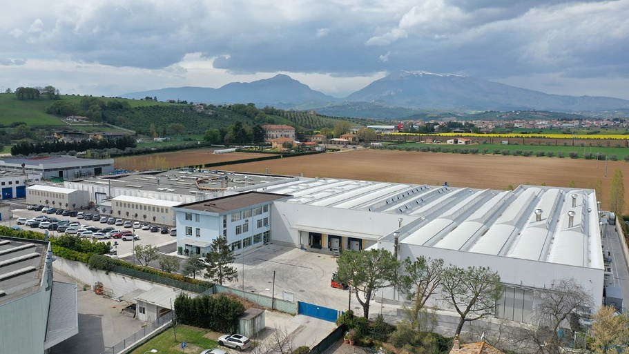
The Freudenberg Apparel Comptence Center in Sant’Omero (Italy)
Source: ©Freudenberg Performance Materials
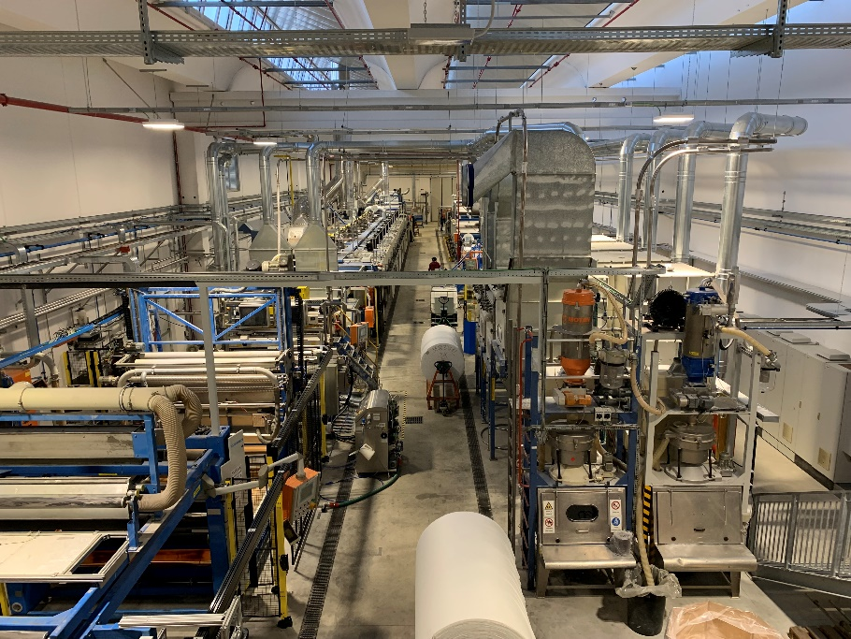
The innovative competence center for coating and finishing of nonwoven, woven and weft meet the highest standards of quality and sustainability.
Source: ©Freudenberg Performance Materials

Contact for media inquiries
Freudenberg Performance Materials Holding GmbH
Holger Steingraeber, SVP Global Marketing & Communications
Hoehnerweg 2-4 / 69469 Weinheim / Germany
Phone +49 6201 7107 007
Holger.Steingraeber@freudenberg-pm.com
www.freudenberg-pm.com

Katrin Boettcher, Manager Global Media Relations
Hoehnerweg 2-4 / 69469 Weinheim / Germany
Phone +49 6201 7107 014
Katrin.Boettcher@freudenberg-pm.com
www.freudenberg-pm.com

About Freudenberg Performance Materials
Freudenberg Performance Materials is a leading global supplier of innovative technical textiles for a broad range of markets and applications such as apparel, automotive, building interiors, building materials, healthcare, energy, filter media, shoe and leather goods as well as specialties. In 2022, the company generated sales of some than €1.6 billion, had 32 production sites in 14 countries around the world and had some 5.000 employees. Freudenberg Performance Materials attaches great importance to social and ecological responsibility as the basis for its business success. For more information, please visit: www.freudenberg-pm.com.
In 2022, the Freudenberg Group employed some 51,000 people in around 60 countries worldwide and generated sales of more than €11,7 billion. For more information, please visit www.freudenberg.com.

