PRESS RELEASE

Freudenberg to introduce advanced foam replacement and to present domestically produced spunlaid at FOAM Expo 2025.

Durham, NC, USA, June 18, 2025. Freudenberg Performance Materials (Freudenberg) will be introducing its advanced foam replacements to the American market and showcasing innovative domestically produced Spunlaid solutions at the FOAM Expo in Novi, Michigan, from June 24th -26th, 2025. The solutions not only highlight Freudenberg´s commitment to quality and sustainability but also reflect its understanding of the future needs of the industry. The impact of its innovative materials can be seen across various applications, from automotive interiors to building and construction, where performance and reliability are paramount. The experts from Freudenberg look forward to meeting visitors at booth 1613.

Introduction to the U.S. market: foam replacement nonwovens
Freudenberg will be introducing a new solution to the American market: innovative foam replacement nonwovens. This innovative advancement is characterized by a lightweight nature combined with enhanced air permeability, a result of its uniquely vertically oriented fiber structure. Such design not only optimizes performance but also contributes significantly to the overall efficiency of various applications.
The implications of this advancement extend beyond mere material properties. By simplifying the thermal forming process for customers, Freudenberg is not only enhancing operational efficiency but also enabling a broader range of industries to adopt sustainable practices without compromising on quality. This innovation serves as a testament to the impact of technology on the future of manufacturing and production methods, highlighting the potential for continuous improvement in sustainability.
Ultimately, Freudenberg’s foam replacement nonwovens underscore the transition towards greener practices across various sectors. As industries evolve, embracing such innovative solutions will be critical in reducing environmental footprints and fostering a sustainable future.
Domestically produced polyester Spunlaid
One of the standout products we are excited to promote at the exhibition is our domestically produced polyester Spunlaid, specifically designed for automotive applications. These Spunlaid materials boast an exceptional strength-to-weight ratio, making them incredibly lightweight and ideal for various uses, including foam adhesion and support layers. Their versatility shines through in applications such as carpet backing, headliners, and interior trim pieces.

Benefits for customers and consumers
Customers and end consumers can expect significant benefits from Freudenberg´s polyester Spunlaid solutions. The impressive strength-to-weight ratio enables manufacturers to downsize parts without compromising integrity, as less material is required. This reduction leads to shorter production times, enhancing overall efficiency and resulting in substantial cost savings. Additionally, the lightweight nature of these materials allows for innovative designs and applications, demonstrating the positive impact of technology on manufacturing processes.

Photo
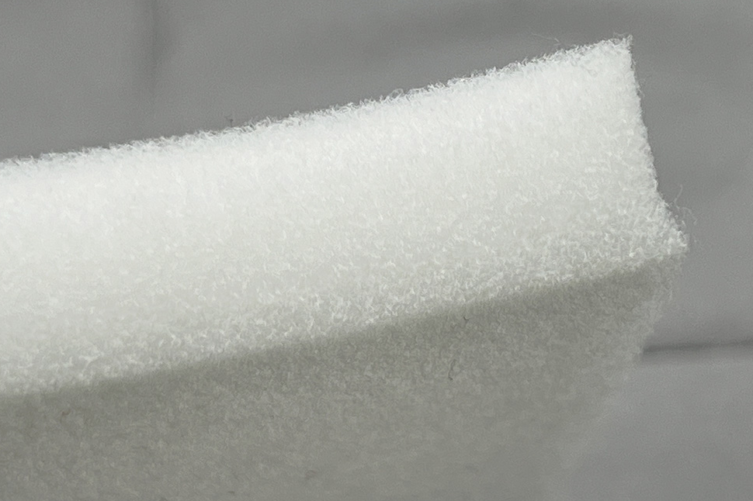
Freudenberg´s first foam replacement nonwovens for the American market.
Source: ©Freudenberg Performance Materials
Contact for media inquiries
Freudenberg Performance Materials Holding GmbH
Katrin Böttcher  Manager Global Media Relations  Höhnerweg 2-4 / 69469 Weinheim / Germany  Phone +49 6201 7107 014  Katrin.Boettcher@freudenberg-pm.com  www.freudenberg-pm.com | Annalena Wahlig  Specialist Marketing & Communications  Höhnerweg 2-4 / 69469 Weinheim / Germany  Phone +49 6201 7107 405  Annalena.Wahlig@freudenberg-pm.com  www.freudenberg-pm.com

About Freudenberg Performance Materials
Freudenberg Performance Materials is a leading global supplier of innovative technical textiles for a broad range of markets and applications such as apparel & shoe, building, civil engineering, energy, filtermedia, healthcare, household & living, industrial & manufacturing, mobility & transport, as well as coated technical textiles. In 2024, the company generated sales of more than €1.4 billion, operated 35 production sites in 14 countries around the world and had around 5,000 employees. Freudenberg Performance Materials attaches great importance to social and ecological responsibility as the basis for its business success. For more information, please visit www.freudenberg-pm.com

In 2024, the Freudenberg Group employed over 52,100 people in around 60 countries worldwide and generated sales of some €11.9 billion. For more information, please visit www.freudenberg.com

