PRESS RELEASE

Fachpack 2025: Freudenberg to present protective packaging solutions for automotive OEMs that target waste prevention and climate goals

Weinheim, Germany, July 17, 2025. Freudenberg Performance Materials (Freudenberg) will showcase packaging materials combining high performance protection, CO₂ emission reduction and waste prevention at Fachpack 2025 in Nuremberg, Germany, from September 23-25. Evolon® packaging solutions offered by Freudenberg are particularly suited for packaging automotive components with sensitive surfaces. The Freudenberg experts are looking forward to welcoming visitors at Stand 3-231 in Hall 3.

Evolon® packaging materials provide superior surface protection for a wide range of automotive parts, including molded plastics and painted elements. The high-end textiles make an important contribution to the quality goals of OEMs and tier suppliers by preventing damage to transported parts and lowering rejection rates.

Recycled content and low CO₂ footprint
Evolon® textiles have a small carbon footprint because their manufacturing process uses low-CO₂ energy, and the fabrics are lightweight and reusable. Furthermore, Evolon® packaging materials are made of up to 85% recycled content. “By replacing virgin raw materials with recycled content, we’ve been able to cut the carbon footprint of our fabric production by 35%. We are actively exploring the possibility of manufacturing Evolon® using 100% recycled content to drive CO₂ emissions down even further,” explains Jean-François Kerhault, Director Global Sales & Marketing General Industry at Freudenberg Performance Materials.

Although Evolon® fabrics are lightweight – from 80gsm to 300gsm – they nevertheless still provide the high mechanical strength properties required for automotive packaging applications. This conserves raw materials and reduces the weight of transported loads. In particular, the new Evolon® Ultra Force is approximately 50% lighter than PVC-based materials with similar high mechanical strength, while containing a minimum 50% recycled content and no PVC.

Waste prevention
Evolon® materials play an important role in decreasing waste when it comes to transporting automotive parts. Above all, the high-end materials provide superior surface performance which directly reduces scrap of transported parts.
In addition, packaging waste is also prevented because Evolon® technical packaging textiles are designed for reusable packaging containers. Single-use packaging is avoided. Moreover, Evolon® packaging material lasts for the entire production cycle of a car model.

Photo:
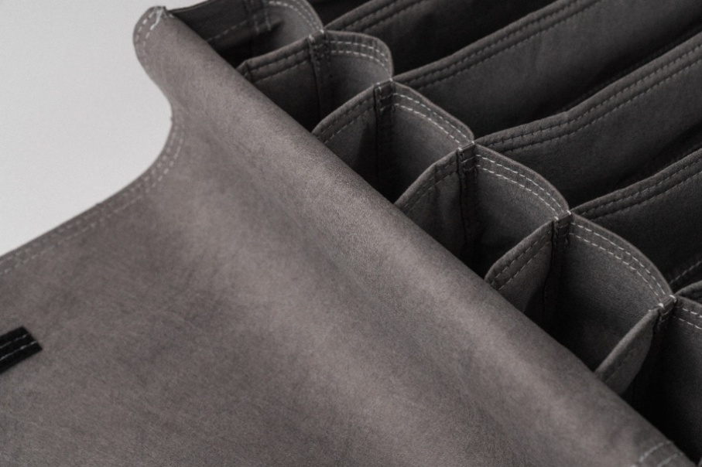
Evolon® sustainable protective packaging
Source: ©Freudenberg Performance Materials

Contact for media inquiries
Freudenberg Performance Materials Holding GmbH
Katrin Böttcher  Manager Global Media Relations  Höhnerweg 2-4 / 69469 Weinheim / Germany  Tel. +49 6201 7107 014  Katrin.Boettcher@freudenberg-pm.com  www.freudenberg-pm.com | Annalena Wahlig  Specialist Marketing & Communications  Höhnerweg 2-4 / 69469 Weinheim / Germany  Tel. +49 6201 7107 405  Annalena.Wahlig@freudenberg-pm.com  www.freudenberg-pm.com

About Freudenberg Performance Materials
Freudenberg Performance Materials is a leading global supplier of innovative technical textiles for a broad range of markets and applications such as apparel & shoe, building, civil engineering, energy, filtermedia, healthcare, household & living, industrial & manufacturing, mobility & transport, as well as coated technical textiles. In 2024, the company generated sales of more than €1.4 billion, operated 35 production sites in 14 countries around the world and had around 5.000 employees. Freudenberg Performance Materials attaches great importance to social and ecological responsibility as the basis for its business success. For more information, please visit www.freudenberg-pm.com
In 2024, the Freudenberg Group employed more than 52,000 people in around 60 countries worldwide and generated sales of some €11,9 billion. For more information, please visit www.freudenberg.com

