**PRESS RELEASE**

**Freudenberg to exhibit for the first time at CAMX 2025 in Orlando, Florida, USA**

**Weinheim, Germany, August 19, 2025.** **Freudenberg Performance Materials (Freudenberg) will be exhibiting for the first time at CAMX 2025 in Orlando, Florida, from September 9-11. This presence is a strong signal from the leading global supplier of technical textiles to support the North American composites industry with high-performance surfacing veils, flow media and spacers. Visitors can meet Freudenberg experts at booth D69 on the show floor.**

Freudenberg’s surfacing veils represent a critical innovation in the realm of Fiber Reinforced Polymer (FRP) components, setting a new standard in material performance and longevity. These veils are not merely functional; they provide a superior level of abrasion resistance and corrosion protection, ensuring that the integrity of the molded part is maintained over time. This is particularly important in applications where environmental stressors can significantly weaken materials. The ability to withstand such conditions not only enhances the product's lifespan but also ensures reliability in critical applications.

**Advanced solutions for piping, UV-resistant facade panels, and more**

Freudenberg’s versatile portfolio of nonwovens includes advanced materials made from glass, PAN, and PET, among others. These high-performance materials are meticulously engineered for various applications, including anti-corrosive layers in piping and tank construction, UV-resistant facade panels, and an array of other end products that are essential in today’s market. A critical component of composite parts, surfacing veils play a vital role in enhancing product durability. Their key attributes include abrasion resistance, corrosion protection, and smooth surfaces, and they also significantly improve mechanical strength. In a world where the impact of environmental factors can compromise structural integrity, these features are particularly important.

**3D polymer filaments from Enka®Solutions optimize resin infusion and foam injection molding**

During CAMX, composite manufacturers will have the opportunity to engage with Freudenberg experts to explore ways to enhance resin infusion and foam injection molding techniques. A particular highlight is the 3D polymeric filament structures from Enka®Solutions used in flow media and spacers. This innovative technology allows manufacturers to achieve significant improvements in quality and efficiency, ensuring that their products adhere to the highest standards.

In processes such as vacuum-assisted resin transfer molding (VARTM) and resin transfer molding (RTM), composites utilizing Enka®Solutions flow media exhibit superior bonding and improved mechanical characteristics, which notably minimizes the likelihood of defects and wrinkling in the final products. The flow media from Enka®Solutions facilitate quick and dependable resin distribution, ensuring complete wetting of the internal structure while maintaining the precise positioning of glass fiber reinforcement nettings and component surfaces. Enka®Solutions offers products specifically designed for efficient resin infusion and foam injection molding applications. Their distinctive 3D entangled polymer filament structures make them highly effective as flow media and spacers in the realm of composite manufacturing.

**Photos:**

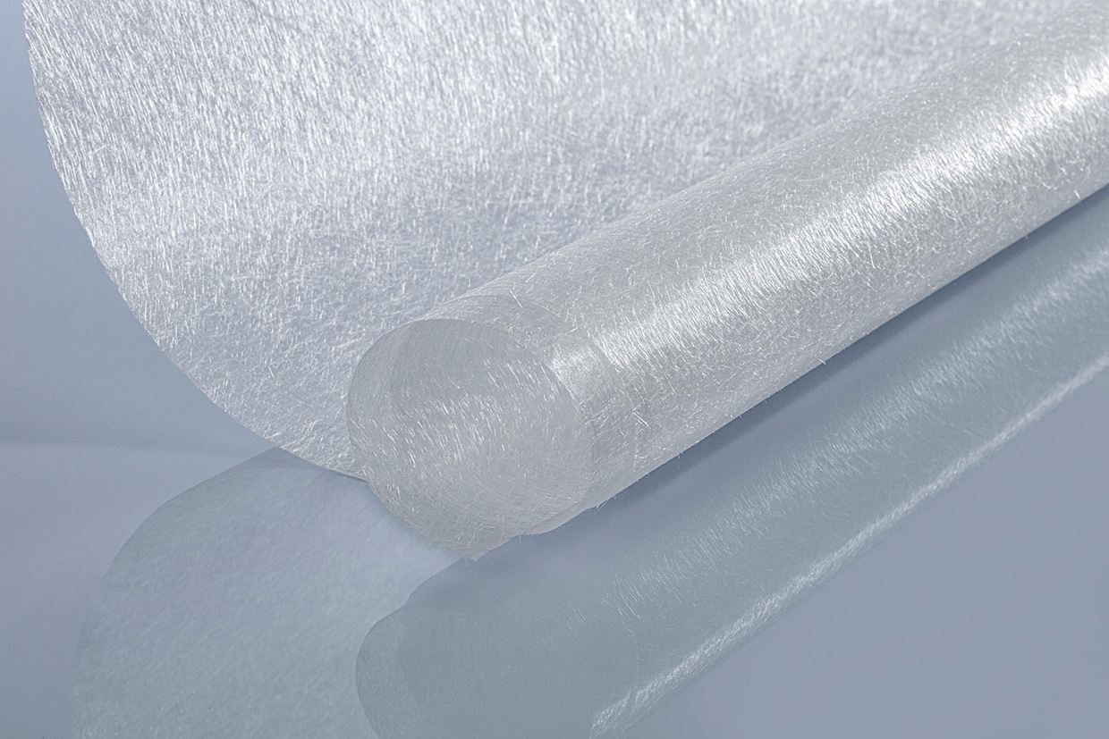

Freudenberg’s glass fiber wetlaid material surfacing veil.

Source: ©Freudenberg Performance Materials

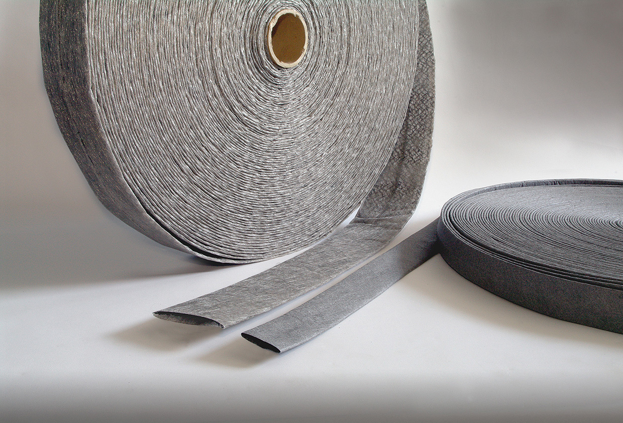

EnkaChannel from Freudenberg: Flow media and spacers in the manufacture of composite materials.

Source: ©Freudenberg Performance Materials

**Contact for media inquiries**

**Freudenberg Performance Materials Holding GmbH**

|  |  |
| --- | --- |
| Katrin Böttcher  Manager Global Media Relations  Höhnerweg 2-4 / 69469 Weinheim / Germany  Tel. +49 6201 7107 014  Katrin.Boettcher@freudenberg-pm.com  www.freudenberg-pm.com | Annalena Wahlig  Specialist Marketing & Communications  Höhnerweg 2-4 / 69469 Weinheim / Germany  Tel. +49 6201 7107 405  Annalena.Wahlig@freudenberg-pm.com  www.freudenberg-pm.com |

**About Freudenberg Performance Materials**

Freudenberg Performance Materials is a leading global supplier of innovative technical textiles for a broad range of markets and applications such as apparel & shoe, building, civil engineering, energy, filtermedia, healthcare, household & living, industrial & manufacturing, mobility & transport, as well as coated technical textiles. In 2024, the company generated sales of more than €1.4 billion, operated 35 production sites in 14 countries around the world and had around 5.000 employees. Freudenberg Performance Materials attaches great importance to social and ecological responsibility as the basis for its business success. For more information, please visit [www.freudenberg-pm.com](http://www.freudenberg-pm.com)

In 2024, the Freudenberg Group employed more than 52,000 people in around 60 countries worldwide and generated sales of some €11,9 billion. For more information, please visit [www.freudenberg.com](http://www.freudenberg.com)