**PRESS RELEASE**

**Freudenberg Performance Materials publishes first Sustainability Report**

**Weinheim, Germany, September 4, 2025 – With the publication of its first sustainability report, Freudenberg Performance Materials has reached a major milestone on its path toward greater environmental responsibility and corporate transparency. Until now, information about the company’s sustainability performance was only included in the sustainability report of its parent company, the Freudenberg Group. The newly released report, however, focuses specifically on the business of technical textiles.**

Sustainability at Freudenberg is more than a strategic necessity – it is deeply rooted in the company’s 175-year history. Freudenberg Performance Materials also aligns with the UN Brundtland definition and aims to minimize waste and emissions while reducing the use of energy, materials, and water. By 2045, the goal is to achieve CO₂ neutrality at all sites (Scope 1 and 2).

**In 2024, Freudenberg Performance Materials made significant progress:**

* CO₂ emissions (Scope 1 & 2) were reduced by another 3% – 29% less than in the base year 2020.
* Despite higher production levels, energy efficiency improved by 10%.
* 30% of all purchased electricity came from renewable sources, powering 25 production lines with green energy.
* The share of green energy in the total energy consumption rose by 26% to 13.5%.
* The company’s biggest gas-powered asset was replaced with wet-scrubber technology, resulting in a reduction of approximately 4,000 tons of CO₂.

In addition, Freudenberg Performance Materials has defined medium- and long-term sustainability goals that serve as guidelines for short-term planning and decision-making. In preparation for the upcoming EU regulation “Ecodesign for Sustainable Products Regulation” (ESPR), the company has begun implementing software to calculate the Product Carbon Footprint (PCF).

**Further information:** [Sustainability Report - Freudenberg Performance Materials](https://www.freudenberg-pm.com/EN/annualreport/sustainabilityreport2024)

**Photo**

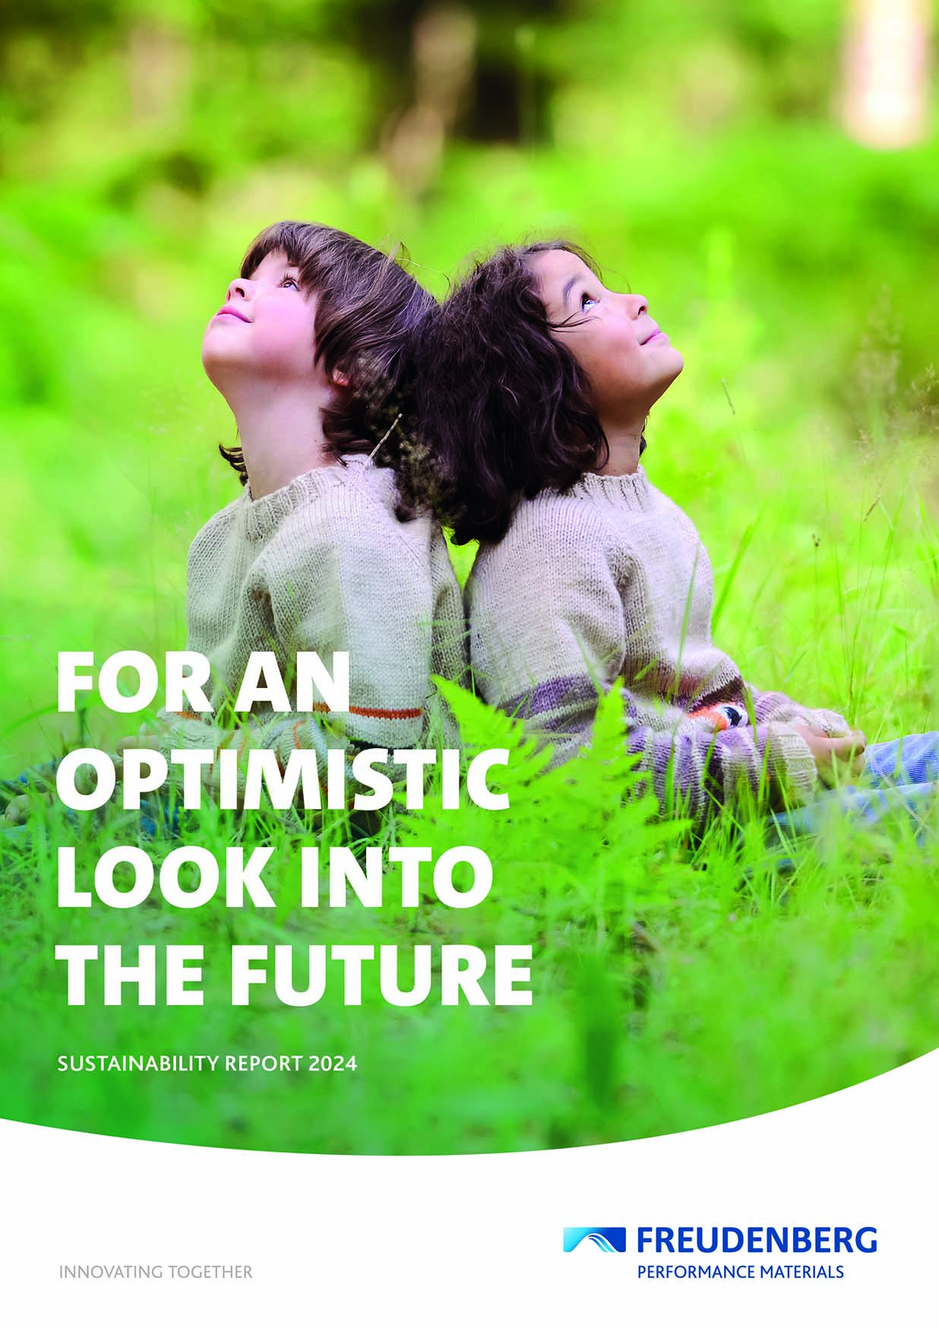

*Freudenberg Performance Materials' first sustainability report shows significant progress.*

Source: ©Freudenberg Performance Materials

**Contact for media inquiries**

**Freudenberg Performance Materials Holding GmbH**

|  |  |  |
| --- | --- | --- |
| |  |  | | --- | --- | | Katrin Böttcher  Manager Global Media Relations  Höhnerweg 2-4 / 69469 Weinheim / Germany  Phone +49 6201 7107 014  [Katrin.Boettcher@freudenberg-pm.com](mailto:Katrin.Boettcher@freudenberg-pm.com)  www.freudenberg-pm.com | Annalena Wahlig  Specialist Marketing & Communications  Höhnerweg 2-4 / 69469 Weinheim / Germany  Phone +49 6201 7107 405  [Annalena.Wahlig@freudenberg-pm.com](mailto:Annalena.Wahlig@freudenberg-pm.com)  www.freudenberg-pm.com | |

Über Freudenberg Performance Materials

Freudenberg Performance Materials is a leading global supplier of innovative technical textiles for a broad range of markets and applications such as apparel & shoe, building, civil engineering, energy, filtermedia, healthcare, household & living, industrial & manufacturing, mobility & transport, as well as coated technical textiles. In 2024, the company generated sales of more than €1.4 billion, operated 35 production sites in 14 countries around the world and had around 5,000 employees. Freudenberg Performance Materials attaches great importance to social and ecological responsibility as the basis for its business success. For more information, please visit www.freudenberg-pm.com

In 2024, the Freudenberg Group employed over 52,100 people in around 60 countries worldwide and generated sales of some €11.9 billion. For more information, please visit www.freudenberg.com