**PRESS RELEASE**

**Freudenberg Performance Materials presents new website: modern design with clear focus on customers and recruitment**

**Weinheim, October 9, 2025 – Freudenberg Performance Materials is pleased to announce the comprehensive relaunch of its website. The new online presence has a much stronger focus on recruitment and customer orientation, a clear structure and a modern design. With its new presence the company is sending a strong signal for a harmonized brand and market presence.**

Consolidating multiple brand pages under the Freudenberg Performance Materials umbrella is a central element of the new website. This unified brand identity provides visitors with an optimal overview of the company’s markets, applications and solutions.

**Added value for customers and job applicants**

The new website provides a much greater depth of information and specifically targets potential customers and job applicants. A further highlight is the new “Markets & Solutions” feature: almost every solution in the company’s portfolio has a dedicated page containing in-depth information.

For international visitors the new website also includes individual welcome pages in the respective national language – a further contribution to global customer orientation.

**Key advantages of the new Freudenberg Performance Materials website:**

* Faster orientation: All relevant information is centrally bundled.
* Modern design: For an enjoyable user experience.
* Clear structure: Overview of markets, applications and solutions.
* Accessible web design: Complies with current standards and is accessible to everyone.

The relaunch of the Freudenberg Performance Materials website underscores the company’s ambition to offer customers and job applicants a modern, informative and user-friendly digital experience.

**Visit the new website at:** [Experts for technical textiles](https://www.freudenberg-pm.com/)

**Photo:**

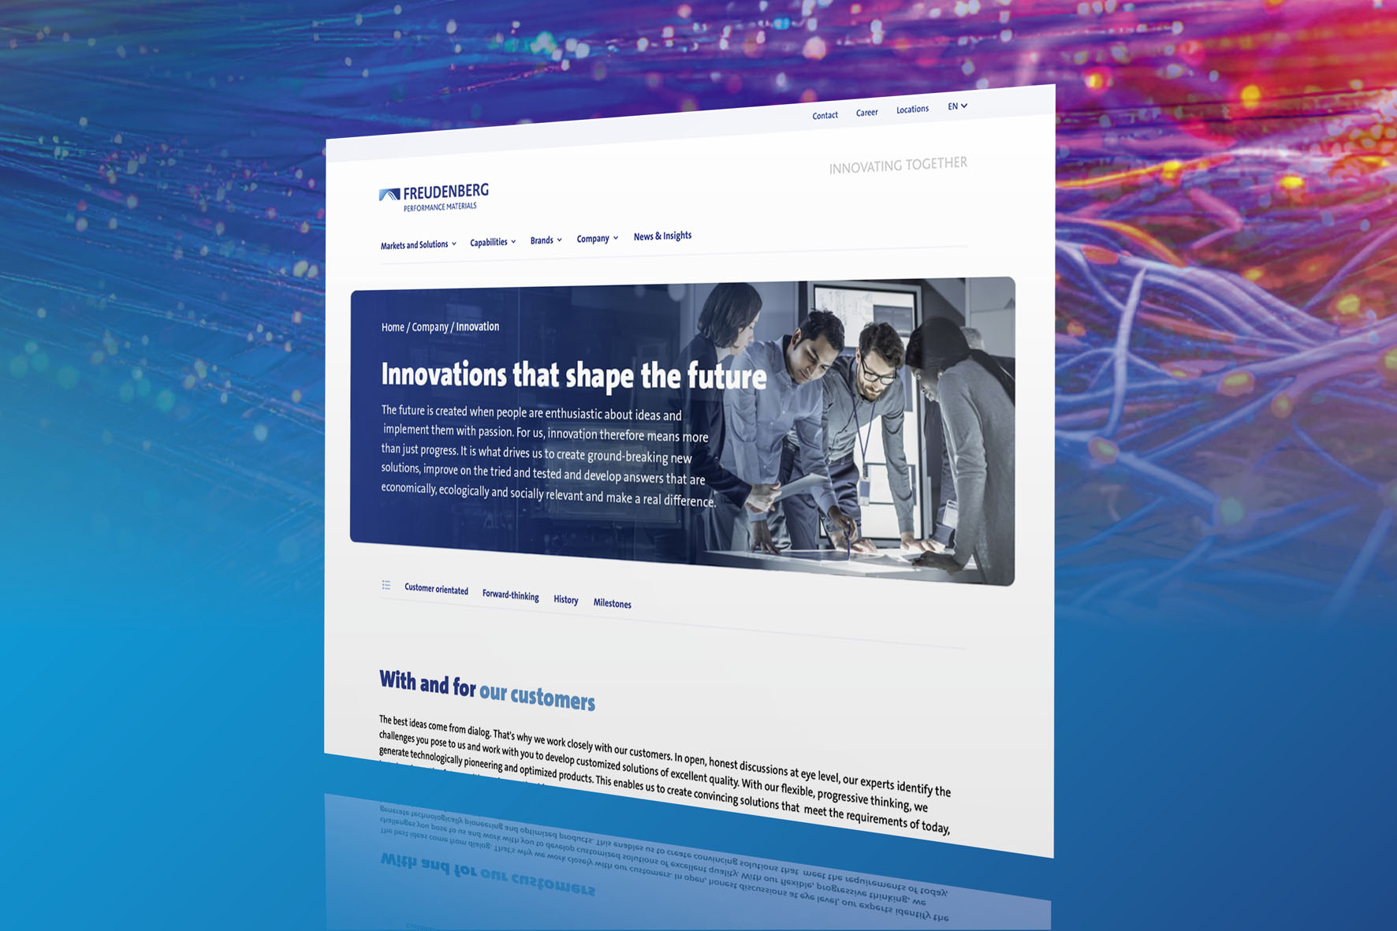

Smarter access, smarter solutions: Freudenberg Performance Materials’ new website.

Source: ©Freudenberg Performance Materials

Contacts for media enquiries

**Freudenberg Performance Materials Holding GmbH**

|  |  |
| --- | --- |
| Katrin Böttcher  Manager Global Media Relations  Höhnerweg 2-4 / 69469 Weinheim / Germany  Tel. +49 6201 7107 014  [Katrin.Boettcher@freudenberg-pm.com](mailto:Katrin.Boettcher@freudenberg-pm.com)  www.freudenberg-pm.com | Annalena Wahlig  Specialist Marketing & Communications  Höhnerweg 2-4 / 69469 Weinheim / Germany  Tel. +49 6201 7107 405  [Annalena.Wahlig@freudenberg-pm.com](mailto:Annalena.Wahlig@freudenberg-pm.com)  www.freudenberg-pm.com |

**About Freudenberg Performance Materials**

Freudenberg Performance Materials is a leading global supplier of innovative technical textiles for a broad range of markets and applications such as apparel & shoe, building, civil engineering, energy, filtermedia, healthcare, household & living, industrial & manufacturing, mobility & transport, as well as coated technical textiles. In 2024, the company generated sales of more than €1.4 billion, operated 35 production sites in 14 countries around the world and had around 5,000 employees. Freudenberg Performance Materials attaches great importance to social and ecological responsibility as the basis for its business success. For more information, please visit [www.freudenberg-pm.com](https://www.freudenberg-pm.com)

In 2024, the Freudenberg Group employed over 52,100 people in around 60 countries worldwide and generated sales of some €11.9 billion. For more information, please visit [www.freudenberg.com](https://www.freudenberg.com)