PRESS RELEASE

Freudenberg accelerates local production for apparel market by expanding its site in India

Weinheim, Germany, October 14, 2025. Freudenberg Performance Materials Apparel (Freudenberg Apparel) celebrates the grand opening of a major expansion at its manufacturing facility in Chennai, India, on October 14, adding 20,000 square feet of production space and introducing new production lines tailored to the Indian apparel market. This strategic investment is aimed at significantly reducing lead times and enhancing the availability of high-quality, locally produced interlinings for the fast-evolving apparel sector in India and South Asia.

The expansion increases the facility’s manufacturing area from 40,000 to 60,000 square feet and introduces specialized production lines for 100% cotton interlinings and 100% polyester interlinings. These new lines especially enable local production of Chinese-equivalent polyester bi-elastic shirt and polyester woven interlinings, meeting rising demand for innovative, premium materials with faster delivery.

Significantly shorter lead times
Equipped with state-of-the-art machinery, the extended facility enhances quality assurance and accelerates production processes. Lead times for Indian manufacturers will be reduced from the 6–8 weeks needed for China imports to just 1–2 weeks with local production. Additionally, customers can expect a cost advantage compared to duty-paid imported goods.

“This expansion marks a milestone in our 27-year journey in India and in our role as a trusted partner in our customers’ growth. When our customers gain speed and margin, we all succeed”, says
CEO Dr. Andreas Raps. “This investment reflects our deep commitment to India’s apparel industry. By localizing production of our advanced bi-elastic shirt and polyester woven interlinings, we’re not only improving speed-to-market but also empowering Indian apparel manufacturers to compete more effectively on the global stage”, adds Jonathan Oh, Senior Vice President & General Manager, Global Apparel Division, Freudenberg Performance Materials.

Support network for Indian textile industry
Since the company expanded into India in 1998, Freudenberg Apparel has developed a support network for the Indian textile industry, including technical solution studios in Chennai, Bangalore, and Gurgaon. These studios provide technical consultations, solution services, technical seminars, trend collection and mockups, interlining recommendation reports, and fusing press audits – services that complement the expanded manufacturing capabilities.

The new production lines join existing paste dot, 3P printing, and powder dot printing capabilities at the Chennai facility, broadening the range of products that can be produced locally.
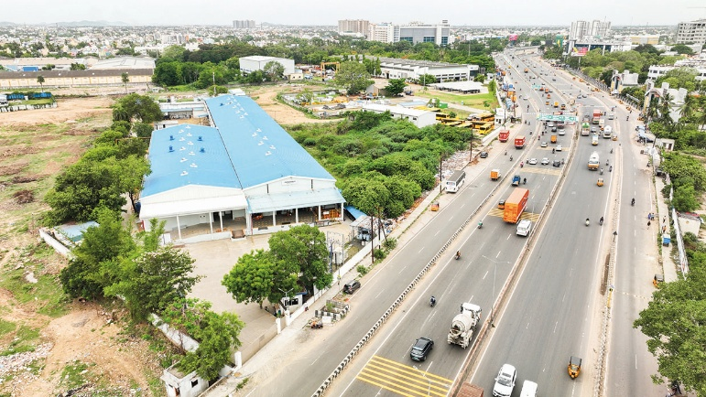
By expanding its production, Freudenberg Apparel is significantly reducing lead times and offering its customers a cost advantage.
Source: ©Freudenberg Performance Materials

Contact for media inquiries
Freudenberg Performance Materials Holding GmbH
Katrin Böttcher  Manager Global Media Relations  Höhnerweg 2-4 / 69469 Weinheim / Germany  Tel. +49 6201 7107 014  Katrin.Boettcher@freudenberg-pm.com  www.freudenberg-pm.com | Annalena Wahlig  Specialist Marketing & Communications  Höhnerweg 2-4 / 69469 Weinheim / Germany  Tel. +49 6201 7107 405  Annalena.Wahlig@freudenberg-pm.com  www.freudenberg-pm.com
About Freudenberg Performance Materials
Freudenberg Performance Materials is a leading global supplier of innovative technical textiles for a broad range of markets and applications such as apparel & shoe, building, civil engineering, energy, filtermedia, healthcare, household & living, industrial & manufacturing, mobility & transport, as well as coated technical textiles. In 2024, the company generated sales of more than €1.4 billion, operated 35 production sites in 14 countries around the world and had around 5.000 employees. Freudenberg Performance Materials attaches great importance to social and ecological responsibility as the basis for its business success. For more information, please visit www.freudenberg-pm.com

In 2024, the Freudenberg Group employed more than 52,000 people in around 60 countries worldwide and generated sales of some €11,9 billion. For more information, please visit www.freudenberg.com

