PRESS RELEASE

Sustainable innovation: Freudenberg launches unique binder-free PLA/wood pulp wetlaid nonwovens
Weinheim, Germany, October 16, 2025. With its new 100% bio-based PLA/wood pulp materials that use no chemical binder, Freudenberg Performance Materials (Freudenberg) has achieved a technological breakthrough with sustainability benefits. These innovative materials combine the advantages of both components, addressing the needs of specific segments within plant propagation systems, packaging, filtration, apparel and healthcare.
Freudenberg's innovation lies in combining the water absorption and biodegradability characteristics of wood pulp with the high strength and hot sealability of PLA. The entire product is 100% bio-based and binder-free.
This unique combination is achieved using the wetlaid process. It represents a technological breakthrough compared to conventional PLA nonwovens, which are made using spunlaid technology. While spunlaid nonwovens can only be produced from polymeric raw materials, wetlaid nonwovens can be manufactured with a mix of polymeric and non-polymeric materials.
Possible applications
These innovative PLA-based wetlaid nonwovens have a variety of applications in markets such as horticulture, packaging, filtration and healthcare.
In horticulture, PLA/wood pulp wetlaid materials achieve the ideal balance between good water absorption, good rooting and degradation properties due to wood pulp on the one hand, and the high strength provided by PLA on the other. These properties are required by short-, medium- and long-term plant propagation systems, e.g. for vegetable growing, flower cultivation and forestry. The new PLA-based product line complements the current range of plant propagation wetlaid materials offered by Freudenberg, based on different component mixes including wood pulp, polypropylene, polyester and viscose.
For packaging, PLA/wood pulp wetlaids open up new sustainable opportunities by replacing plastic-based packaging, e.g. bio-based desiccant bags to replace traditional synthetic desiccant bags.
Other applications of PLA-based wetlaids include embroidery backings and interlinings for apparel, and wound dressings for the healthcare market.
The two-component mix is flexible, therefore allowing for a wide range of products to fulfill the requirements of the various applications.
Photo:
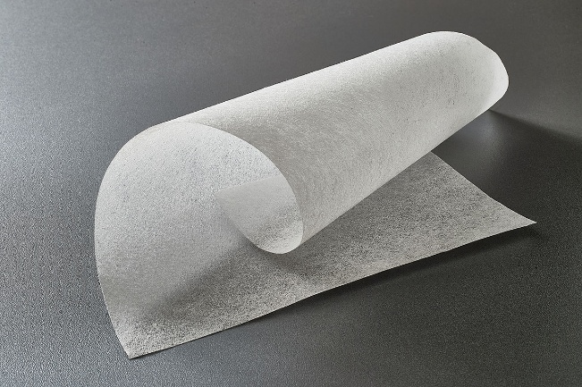
PLA-based wetlaid material made by Freudenberg
Source: ©Freudenberg Performance Materials

Contact for media inquiries
Freudenberg Performance Materials Holding GmbH
Katrin Böttcher  Manager Global Media Relations  Höhnerweg 2-4 / 69469 Weinheim / Germany  Tel. +49 6201 7107 014  Katrin.Boettcher@freudenberg-pm.com  www.freudenberg-pm.com | Annalena Wahlig  Specialist Marketing & Communications  Höhnerweg 2-4 / 69469 Weinheim / Germany  Tel. +49 6201 7107 405  Annalena.Wahlig@freudenberg-pm.com  www.freudenberg-pm.com

About Freudenberg Performance Materials
Freudenberg Performance Materials is a leading global supplier of innovative technical textiles for a broad range of markets and applications such as apparel & shoe, building, civil engineering, energy, filtermedia, healthcare, household & living, industrial & manufacturing, mobility & transport, as well as coated technical textiles. In 2024, the company generated sales of more than €1.4 billion, operated 32 production sites in 14 countries around the world and had around 5.000 employees. Freudenberg Performance Materials attaches great importance to social and ecological responsibility as the basis for its business success. For more information, please visit www.freudenberg-pm.com

In 2024, the Freudenberg Group employed more than 52,000 people in around 60 countries worldwide and generated sales of some €11,9 billion. For more information, please visit www.freudenberg.com

