PRESS RELEASE
Freudenberg launches Tacnera® at EWMA 2026: technology enables next generation of silicone-based foam dressings
Resolves the dilemma between adhesive strength and skin protection
Weinheim, April 16, 2026. With Tacnera®, Freudenberg Performance Materials (Freudenberg) is presenting a new technology for silicone foam dressings used in advanced wound care. Unlike classic silicone adhesive layers, Tacnera® is a highly-developed, intelligently-engineered system that combines polyurethane foam, a proprietary coating technology and gentle silicone gel. Tacnera® therefore solves a key problem for premium foam dressings: the dilemma between reliable adhesion and the risk of skim trauma during dressing changes. This gives brand manufacturers, distributors and regional suppliers of advanced wound care products a clear competitive advantage in the premium segment. The globally active nonwovens manufacturer will be welcoming visitors to Stand D42 at EWMA in Bremen from May 6 – 8.
Foam dressings with particularly gentle silicones often do not adhere firmly enough, while stronger silicones increase the risk of skin trauma and tissue damage. This “adhesion-trauma dilemma” reduces both patient comfort and clinical confidence, and limits market differentiation options in the premium segment. Tacnera® resolves this dilemma.
Two silicones in a single wound dressing: adhesion exactly where it is needed
Foam dressings based on Tacnera® technology enable a combination of two silicones with different properties in a single foam dressing. While one type of silicone coating ensures strong edge adhesion for reliable fixation, a second, particularly gentle coating in the ultra-soft island zone protects sensitive skin structures and newly-formed tissue. This is achieved by a precisely-engineered foam and a wave-patterned coating designed to specifically improve contouring, flexibility and exudate management.
User-friendly and reliable
The result is a foam dressing that reliably stays in place even when used on wounds in hard-to-heal locations, while also ensuring gentle and painless removal. The dressing delivers a consistent performance, thereby supporting both the quality of care and the confidence of users and patients. The technology therefore generates new opportunities for brand manufacturers, distributors and regional suppliers to position themselves in the advanced wound care premium segment.
“Foam dressings based on the innovative Tacnera® technology have a fundamentally new, systemic approach: they combine secure fixation, gentle removal, reliable functioning and commercial viability in a single product,” commented Dr. Oliver Heneric, SVP Division Healthcare at Freudenberg Performance Materials.
Faster to market: economic benefits for customers
In addition to the functional advantages, customers also enjoy clear economic benefits: engineering high-performance silicone-based foam dressings usually entails long development times, specialized know-how and a high technical risk. Tacnera®-based foam dressings are a production-ready, high-performance and ready-to-sell solution, so customers can enter the market faster and reduce development costs. Marketing authorization in Europe is expected in summer 2026.
More innovative solutions for advanced wound care
Freudenberg will also be showcasing next-generation polyurethane foams, super-absorbent nonwovens for improved exudate management, activated carbon components, and an open-cell foam for improved wound cleaning.

Images:

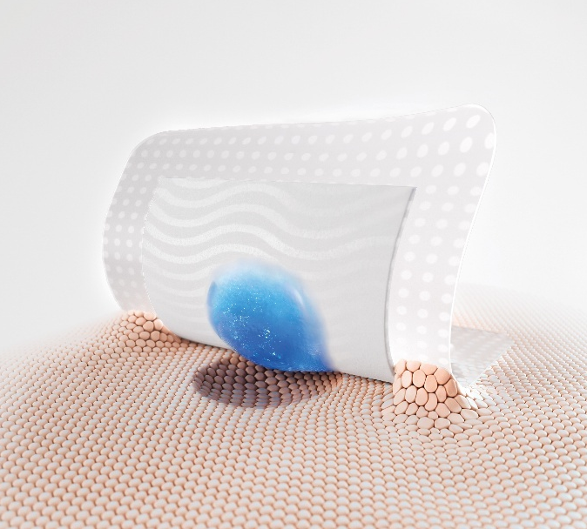
Tacnera® from Freudenberg solves the adhesion-trauma problem.

Source: ©Freudenberg Performance Materials

Contacts for media inquiries

Freudenberg Performance Materials Holding GmbH
Katrin Böttcher  Manager Global Media Relations  Höhnerweg 2-4 / 69469 Weinheim /Germany  Phone +49 6201 7107 014  Katrin.Boettcher@freudenberg-pm.com  www.freudenberg-pm.com | Annalena Wahlig  Specialist Marketing & Communications  Höhnerweg 2-4 / 69469 Weinheim / Germany  Phone +49 6201 7107 405  Annalena.Wahlig@freudenberg-pm.com  www.freudenberg-pm.com

About Freudenberg Performance Materials
Freudenberg Performance Materials is a leading global supplier of innovative technical textiles for a broad range of markets and applications such as apparel & footwear, building, civil engineering, energy, filter media, healthcare, household & living, industrial & manufacturing, mobility & transport, as well as coated technical textiles. In 2025, the company generated sales of more than €14.4 billion, operated 35 production sites in 14 countries around the world and had around 5,100 employees. Freudenberg Performance Materials attaches great importance to social and ecological responsibility as the basis for its business success. For more information, please visit www.freudenberg-pm.com

In 2025, the Freudenberg Group employed around 52,000 people in around 60 countries worldwide and generated sales of some €11.7 billion. For more information, please visit www.freudenberg.com

