PRESS RELEASE

Freudenberg Performance Materials acquires Foshan United Medical
Expansion into full-service supplier on global market for advanced wound care
Weinheim, Germany, July 31, 2026. Effective July 31, 2026, Freudenberg Performance Materials (Freudenberg), a leading global manufacturer of technical textiles, has acquired Foshan United Medical Ltd. (UMT). The sellers are UMT founder Dr Xiaodong Wang and a private Chinese founding partner. UMT is a leading full-service supplier of advanced wound care products. The company with headquarters and state-of-the-art production facilities in Foshan, China, has a workforce of some 200. The parties have agreed not to disclose the purchase price.

“Freudenberg Performance Materials and Foshan United Medical are a perfect strategic match. Going forward, the merger will enable us to offer a unique portfolio of technologies and products as an innovative full-service supplier in the market for advanced wound care”, Dr. Andreas Raps, CEO of Freudenberg Performance Materials, commented. Dr. Xiadong Wang, CEO and founder of UMT, underscored: “The innovative strength and high level of customer orientation characteristic of both our companies make for an ideal fit, they are the cornerstone for expanding our success.”

State-of-the-art technologies and regulatory know-how
UMT has state-of-the-art technologies at its disposal. Core competencies range from fiber manufacturing or functionalization to nonwoven production and final packaging, sterilization and marketing authorization.
UMT’s regulatory know-how, successful international first approvals for products as well as patents granted in China, Europe and the USA are another key element for expanding the healthcare business of Freudenberg Performance Materials.
Individual solutions for customers
With the UMT takeover, Freudenberg Performance Materials can cover all important steps in the value chain in-house, and thus offer one of the broadest technology platforms in the market for advanced wound care. In future, the company will provide a wide range of solutions for different applications: dressings made of polyurethane foam, with silicone coatings or antimicrobial agents such as silver. Alginate-based absorbent fiber solutions, chitosan- and CMC-based wound dressings supplement the portfolio. The broad technological foundation unlocks comprehensive options for individual adaptation and enables tailormade solutions for customers all over the world.

Photo
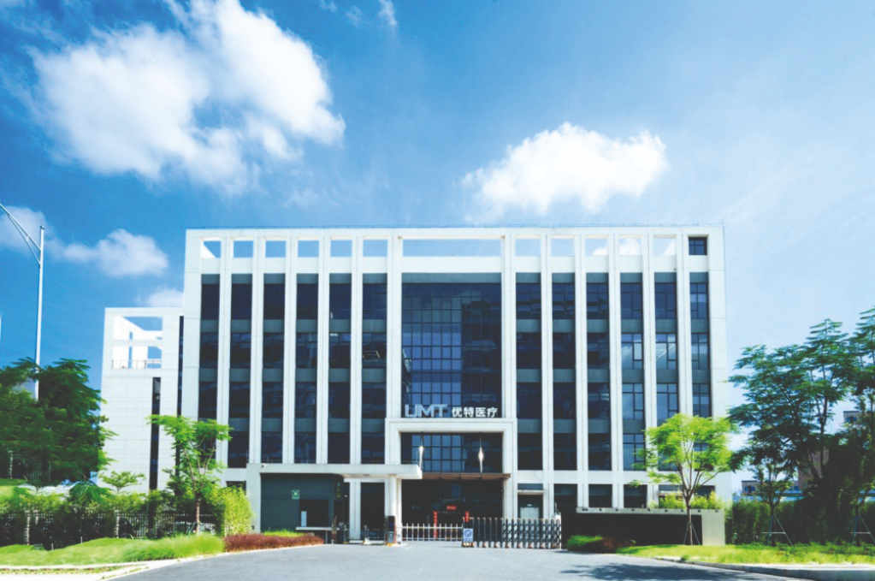
With UMT, Freudenberg Performance Materials becomes a full-service provider of advanced wound care.
Source: ©Freudenberg Performance Materials

Contacts for media inquiries
Freudenberg Performance Materials Holding GmbH
Holger Steingräber  SVP Corporate Marketing & Communications  Höhnerweg 2-4 / 69469 Weinheim / Germany  Tel. +49 6201 7107 007  Holger.Steingraeber@freudenberg-pm.com  www.freudenberg-pm.com | Katrin Böttcher  Manager Global Media Relations  Höhnerweg 2-4 / 69469 Weinheim / Germany  Tel. +49 6201 7107 014  Katrin.Boettcher@freudenberg-pm.com  www.freudenberg-pm.com
About Freudenberg Performance Materials
Freudenberg Performance Materials is a leading global supplier of innovative technical textiles for a broad range of markets and applications such as apparel & footwear, building, civil engineering, energy, filter media, healthcare, household & living, industrial & manufacturing, mobility & transport, as well as coated technical textiles. In 2025, the company generated sales of more than €1.4 billion, operated 35 production sites in 14 countries around the world and had around 5,100 employees. Freudenberg Performance Materials attaches great importance to social and ecological responsibility as the basis for its business success. For more information, please visit www.freudenberg-pm.com
In 2025, the Freudenberg Group employed around 52,000 people in around 60 countries worldwide and generated sales of some €11.7 billion. For more information, please visit www.freudenberg.com

