PRESS RELEASE
Freudenberg Performance Materials and UMT exhibiting together at WUWHS 2026

Weinheim, September 9, 2026. Freudenberg Performance Materials (Freudenberg), a leading global manufacturer of technical textiles, will be exhibiting alongside Foshan United Medical Technologies Ltd. (UMT) at the World Union of Wound Healing Societies (WUWHS) Congress in Kuala Lumpur, Malaysia. The trade fair marks the first time Freudenberg and UMT will be participating together since Freudenberg acquired the wound care specialist effective July 31, 2026. The event takes place at the Kuala Lumpur Convention Centre from September 23 to 27, 2026. The experts look forward to engaging with visitors at Booth 11-12 on Level 3, Hall 7A/B/C.

Freudenberg and UMT will be showcasing their combined technology and product portfolio for advanced wound care at the WUWHS in Kuala Lumpur, Malaysia. The focus will be on UMT’s wound dressings based on alginate, carboxymethyl cellulose (CMC) and chitosan as well as a wound closure device. The portfolio will be complemented by Tacnera®, Freudenberg’s patented technology for silicone-coated foam dressings. “With our first joint trade fair appearance we are demonstrating the tangible added value that combining the expertise of Freudenberg Performance Materials and UMT brings our customers. We offer one of the broadest technology platforms in the advanced wound care market – all under one roof,” said Dr. Oliver Heneric, SVP Division Healthcare at Freudenberg Performance Materials.

Comprehensive portfolio for advanced wound care
The portfolio covers a range of complementary solutions addressing different clinical requirements. UMT's alginate dressings are widely used for their high absorption capacity, while silver alginate variants provide the added benefit of antimicrobial protection for infected wounds and wounds at increased risk of infection. The CMC dressing combines effective moisture management with proven gelling technology to create a favorable healing environment, and the chitosan wound dressing leverages the natural hemostatic and bacteriostatic properties of chitosan.

Visitors will also have the opportunity to learn more about UMT's wound closure device, a non-invasive alternative for the closure of surgical and superficial acute wounds. The device is designed to reduce tissue trauma while supporting favorable aesthetic results.
To complement these primary wound care solutions, Freudenberg offers silicone foam dressings featuring Tacnera®, an advanced technology developed to provide secure fixation and atraumatic removal. Its unique dual-silicone technology combines strong adhesion at the dressing border with a particularly gentle silicone layer in the wound contact area, helping to protect fragile and newly formed tissue. A specially designed wave-pattern coating further enhances flexibility, adaptability and exudate handling, making Tacnera® an effective secondary dressing option within a comprehensive wound care strategy.

Joint presence demonstrates strong strategic synergies
Freudenberg acquired UMT effective July 31, 2026. UMT is a full-service provider of advanced wound care products with headquarters and production facilities in Foshan, China. The company’s core competencies range from fiber manufacturing or functionalization to nonwoven production and final packaging, sterilization, and marketing authorization. With the merger, Freudenberg is expanding its existing technology and product portfolio and strengthening its position as a full-service provider in the global advanced wound care market.

Images

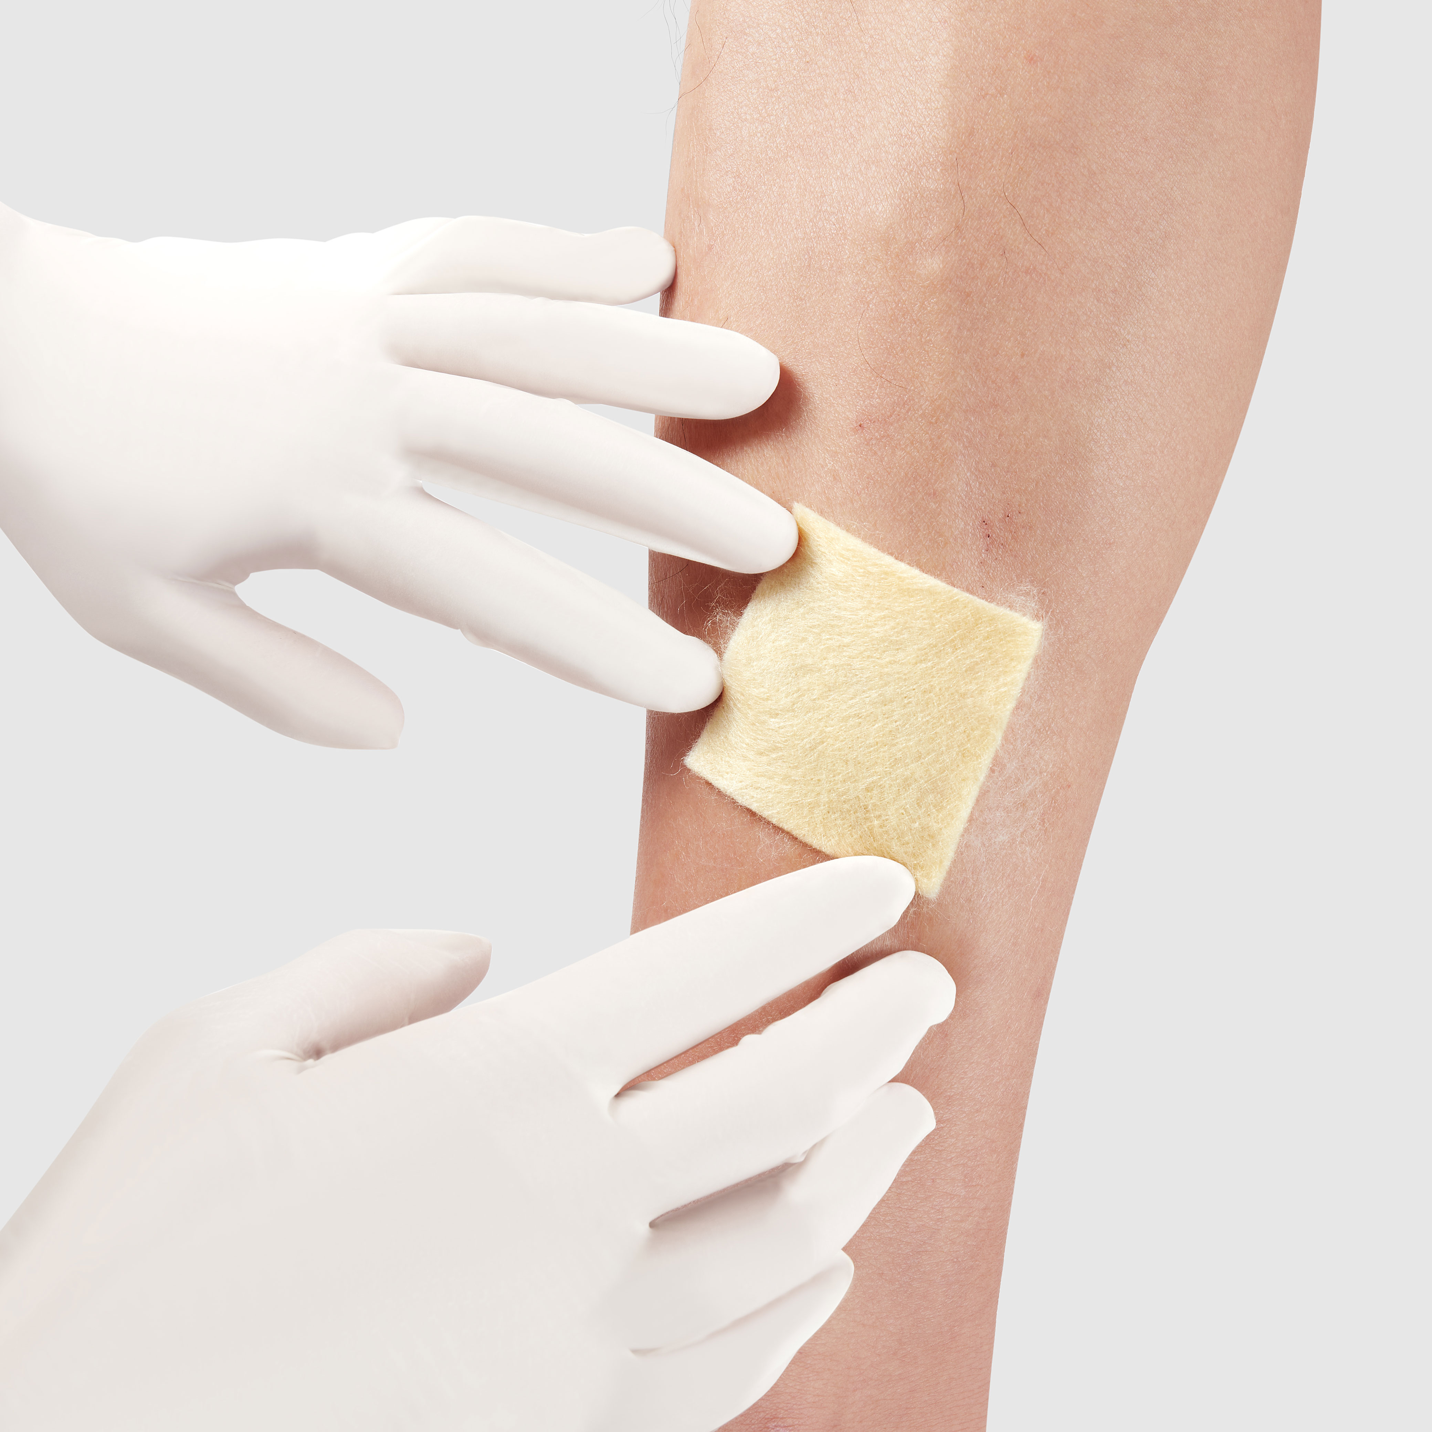
The chitosan dressing from UMT absorbs wound exudate and creates an appropriate healing environment.
Source: ©Freudenberg Performance Materials
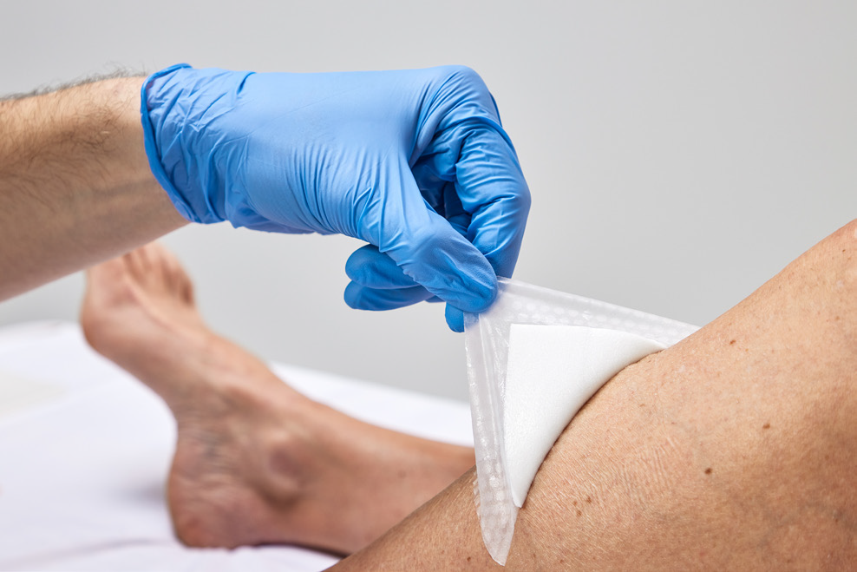
Tacnera®: Freudenberg’s innovative technology for silicone-coated secondary foam dressings.
Source: ©Freudenberg Performance Materials

Contacts for media inquiries
Freudenberg Performance Materials Holding GmbH

Katrin Böttcher  Manager Global Media Relations  Höhnerweg 2-4 / 69469 Weinheim / Germany  Tel. +49 6201 7107 014  Katrin.Boettcher@freudenberg-pm.com  www.freudenberg-pm.com | Annalena Wahlig  Specialist Marketing & Communications  Höhnerweg 2-4 / 69469 Weinheim / Germany  Tel. +49 6201 7107 405  Annalena.Wahlig@freudenberg-pm.com  www.freudenberg-pm.com
About Freudenberg Performance Materials
Freudenberg Performance Materials is a leading global supplier of innovative technical textiles for a broad range of markets and applications such as apparel & footwear, building, civil engineering, energy, filter media, healthcare, household & living, industrial & manufacturing, mobility & transport, as well as coated technical textiles. In 2025, the company generated sales of more than €1.4 billion, operated 35 production sites in 14 countries around the world and had around 5,100 employees. Freudenberg Performance Materials attaches great importance to social and ecological responsibility as the basis for its business success. For more information, please visit www.freudenberg-pm.com
In 2025, the Freudenberg Group employed around 52,000 people in around 60 countries worldwide and generated sales of some €11.7 billion. For more information, please visit www.freudenberg.com

