PRESS RELEASE
COMPAMED 2026: Freudenberg and UMT jointly present extended portfolio for advanced wound care
Weinheim, November 5, 2026. With the merger of Freudenberg Performance Materials (Freudenberg) and UMT, customers gain access to a broader range of solutions for advanced wound care. The joint portfolio includes gelling wound dressings based on CMC, alginate and chitosan, solutions for non-invasive wound closure, silicone-coated foam dressings, nonwovens and foams for wound care as well as activated carbon solutions for stoma care. The globally active manufacturer will be welcoming visitors to Booth H01 in Hall 8b at the medtech trade fair in Düsseldorf from
November 16 to 19, 2026.

Freudenberg und UMT are showcasing their complementary know-how for advanced wound care. Tacnera® from Freudenberg enables a unique approach to silicone-coated foam dressings, while UMT complements the portfolio with additional technologies, including alginate, CMC, and chitosan dressings, as well as a solution for non-invasive wound closure.

Gelling wound dressings for effective exudate management
The trade fair presentation focuses on gelling wound dressings based on carboxymethyl cellulose (CMC), alginate and chitosan. The materials absorb wound exudate, forming a gel which assists in maintaining an optimal wound environment. They can be used in particular for chronic and complex wounds.

Tacnera® combines reliable fixation with gentle wound contact
Another highlight at the booth is Tacnera® - since September 2026, the technology has been approved in several products and will soon be available on the market. It was developed to resolve the dilemma between reliable adhesion and gentle wound dressing removal. While strong edge adhesion ensures secure fixation, the ultra-soft Tacnera® island zone protects sensitive structures and new epithelial tissue.
Tacnera® can be combined with UMT’s primary wound dressings. A gelling dressing made of CMC, alginate or chitosan absorbs exudate within the wound bed and optimizes the wound environment, while the overlying Tacnera® foam dressing complements the primary dressing and, thanks to its conformability, helps prevent dead space and exudate pooling. In this way, the functions of the different materials complement each other within a coordinated care concept.
“Today, customers are increasingly looking for integrated solutions that help them accelerate development processes, simplify supply chains, and meet regulatory requirements. By combining Freudenberg’s material expertise and global market presence with UMT’s development, manufacturing and application know-how, we can support customers throughout the entire product life cycle”, explains Shirley Xu, Senior Business Development Manager at Freudenberg Performance Materials.
Trade visitors to the booth can find out more about gelling wound dressings, silicone-coated foam dressings based on Tacnera® technology, solutions for non-invasive wound closure, as well as other materials and technologies for medical applications. The company is exhibiting at the trade fair at a shared booth with its sister company, Freudenberg Medical.
Images:
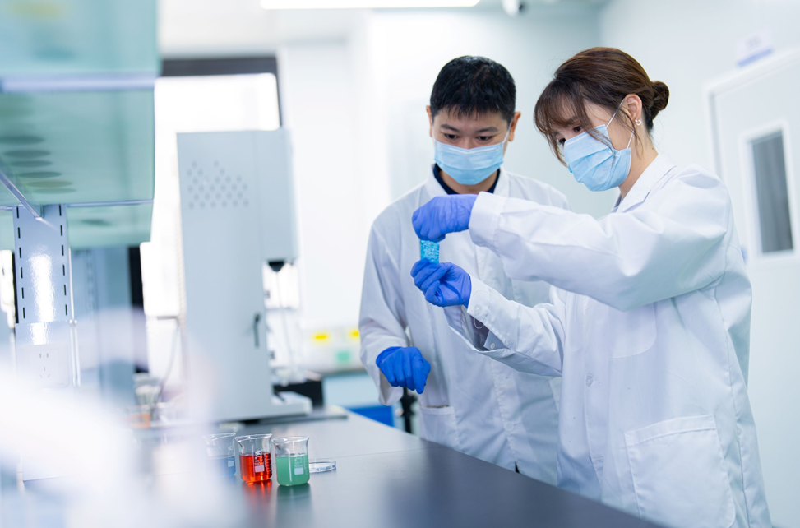

CMC Material Quality Trial at Freudenberg’s UMT Laboratory.
Source: ©Freudenberg Performance Materials

Contacts for media inquiries
Freudenberg Performance Materials Holding GmbH
Katrin Böttcher  Manager Global Media Relations  Höhnerweg 2-4 / 69469 Weinheim / Germany  Tel. +49 6201 7107 014  Katrin.Boettcher@freudenberg-pm.com  www.freudenberg-pm.com | Annalena Wahlig  Specialist Global Media Relations  Höhnerweg 2-4 / 69469 Weinheim / Germany  Tel. +49 6201 7107 405  Annalena.Wahlig@freudenberg-pm.com  www.freudenberg-pm.com

About Freudenberg Performance Materials
Freudenberg Performance Materials is a leading global supplier of innovative technical textiles for a broad range of markets and applications such as apparel & footwear, building, civil engineering, energy, filter media, healthcare, household & living, industrial & manufacturing, mobility & transport, as well as coated technical textiles. In 2025, the company generated sales of more than €1.4 billion, operated 35 production sites in 14 countries around the world and had around 5,100 employees. Freudenberg Performance Materials attaches great importance to social and ecological responsibility as the basis for its business success. For more information, please visit www.freudenberg-pm.com
In 2025, the Freudenberg Group employed around 52,000 people in around 60 countries worldwide and generated sales of some €11.7 billion. For more information, please visit www.freudenberg.com

