PRESS RELEASE

Dual protection: Evolon® ESD packaging textile prevents electrostatic discharge and protects sensitive surfaces from damage

Weinheim, February 16, 2023. Freudenberg Performance Materials (Freudenberg) is widening its product range of technical packaging textiles. Evolon® ESD protects automotive and industrial parts with electronic components from electrostatic discharge. This includes trim lines, dashboards, mirrors, steering wheels, etc. In addition, Evolon® ESD prevents scratching of very sensitive surfaces. The new technical packaging textile also provides several sustainability benefits: it helps manufacturers to reduce their scrap waste, it is long-lasting, and is made from recycled polyester.

The ESD (ElectroStatic Discharge) feature of the new Evolon® technical packing textile provides permanent electrostatic discharging protection and the fabric’s surface resistivity can be customized. This eliminates ESD damage to electronic components during transport because electrostatic charging due to movement and friction is safely prevented. As this kind of damage cannot be detected with the naked eye, Evolon® ESD helps to avoid failures which can occur after the final product is assembled and released. Manufacturers benefit from fewer complaints and warranty costs, as well as better end customer satisfaction.

Further protection feature
Unlike conventional ESD packaging solutions, Evolon® ESD also protects parts surfaces by avoiding micro-scratches or lint contamination. By using Evolon® reusable packaging to transport parts with highly-sensitive surfaces, customers reduce the number of damaged parts and the reject rate.

Additional benefits
Evolon® microfilament textiles are also extremely strong and are available in different weights to meet a wide range of requirements – from lightweight to heavy-duty. They can be used to pack and transport very heavy parts without damage. In addition, Evolon® fabrics are extremely durable, and contain up to 85% recycled PET.

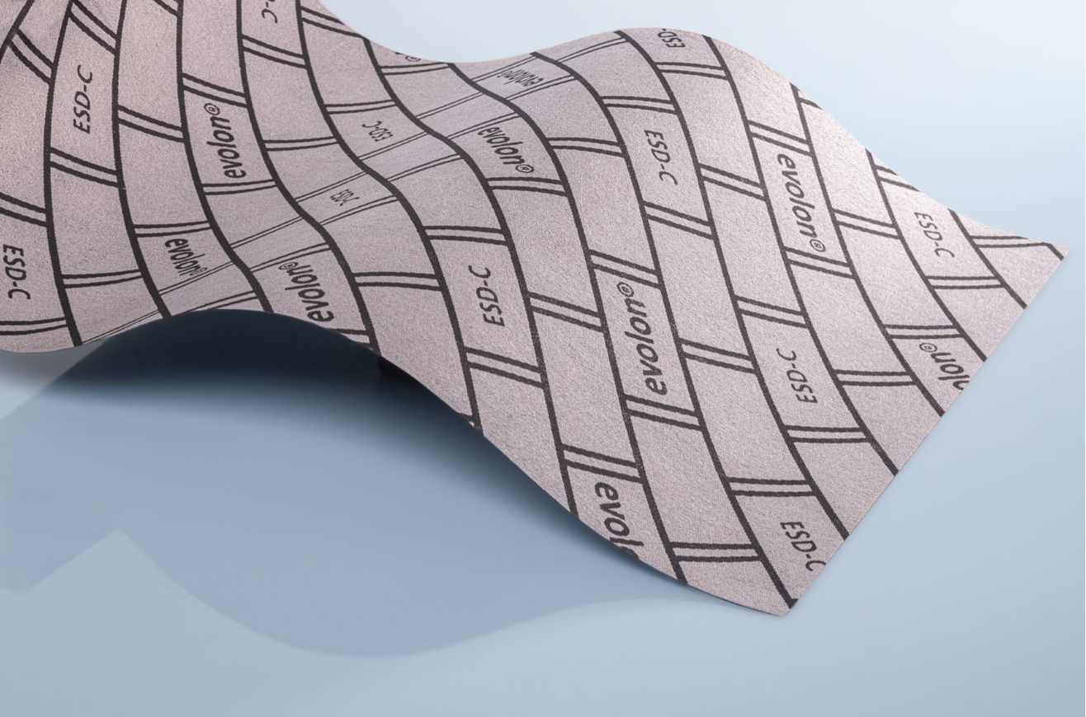

Contact for media inquiries
Freudenberg Performance Materials Holding SE & Co. KG
Holger Steingraeber, SVP Global Marketing & Communications
Höhnerweg 2-4 / 69469 Weinheim / Germany
Phone +49 6201 7107 007
Holger.Steingraeber@freudenberg-pm.com
www.freudenberg-pm.com

Katrin Böttcher, Manager Global Media Relations
Höhnerweg 2-4 / 69469 Weinheim / Germany
Phone +49 6201 7107 014
Katrin.Boettcher@freudenberg-pm.com
www.freudenberg-pm.com

About Freudenberg Performance Materials
Freudenberg Performance Materials is a leading global supplier of innovative technical textiles for a broad range of markets and applications such as apparel, automotive, building interiors, building materials, healthcare, energy, filter media, shoe and leather goods as well as specialties. In 2021, the company generated sales of more than €1.3 billion, had 33 production sites in 14 countries around the world and had some 5.000 employees. Freudenberg Performance Materials attaches great importance to social and ecological responsibility as the basis for its business success. For more information, please visit www.freudenberg-pm.com
The company is a Business Group of Freudenberg Group. In 2021, the Freudenberg Group employed some 50,000 people in around 60 countries worldwide and generated sales of more than €10 billion. For more information, please visit www.freudenberg.com.

